CSDT330T–TSecurityTAnalytics

  - HomeworkT#2

TheoreticalTExercises
1.TWhyTwouldTURLTinvestigationThelpTinTsecurity/privacy?TGiveTatTleastTthreeTdifferentTapplicationsTfromTsecurity/privacyTinTwhichTitTcouldTbeTuseful.

Answer:

  - ATUniformTResourceTLocator,TcolloquiallyTtermedTaTwebTaddress,TisTaTreferenceTtoTaTwebTresourceTthatTspecifiesTitsTlocationTonTaTcomputerTnetworkTandTaTmechanismTforTretrievingTit.TATURLTisTaTspecificTtypeTofTUniformTResourceTIdentifier,TalthoughTmanyTpeopleTuseTtheTtwoTtermsTinterchangeably.TItTisTbasicallyTaTsetTofTdirectionsTforTaTwebTbrowserTtoTreachTaTwebpage/file.
  - ByTexaminingTtheTURLTweTcanTtryTtoTdetermineTtheTdestinationTofTtheTURLTwithoutTactuallyTclickingTonTtheTURL.TWeTcanTthenTdecideTtoTproceedTclickingTonTitTifTitTcomesTfromTaTtrustedTsourceTandTleadsTtoTaTtrustedTdestination.TIfTanythingTsuspiciousTorTaTbunchTofTstrangeTcharactersTareTfoundTinTURLTinvestigationTweTshouldTreportTtheTURLTorTuseTaTlinkTscannerTtoTvalidateTitTandTdefinitelyTnotTclickTit,TasTitTmayTcontainTdirectionsTtoTsomeTmalwareTorTotherTmaliciousTfiles/sites.
  - WeTuseTURLTInvestigationTtoTpreventTusersTfromTaccessingTwebsitesTthatTprovideTcontentTthatTisTobjectionable,TpotentiallyTharmful,TorTnotTwork-related.TApplicationsTofTURLTinvestigationT–
  - a)TDetectionTofTMaliciousTObjectsT–TThereTareTmanyTanti-virusTsoftwareTsuchTasTKasperskyTwhichTusTURLTinvestigationTtoTclassifyTURLsTintoTdifferentTcategoriesTsuchTasT–T
  - •TGoodT–TURLTnotTmalicious.T
  - •TDangerousT–TMaliciousTobjectsTrelatedTtoTtheTURL.T
  - •TAdwareTandTOtherT–TObjectsTrelatedTtoTtheTURL,TwhichTareTclassifiedTasTNOT-avirus.T
  - •TNotTcategorisedT–TNoTinformationTaboutTtheTURLTisTavailable

  - b)TDetectionTofTPhishingTWebsiteTandTEmailsT–TEmailsTthatTclaimTtoTbeTfromTwellTknowTbanksTandTorganisationTandThaveTlinksTforTtheTuserTtoT“verifyTtheirTinformation”TareToftenTphishingTmails.TWeTshouldTinspectTtheTlinkTcarefullyTandTcheckTitTlegitimacyTbeforeTclickingTonTit.TMultipleTsoftwares,TsuchTasTPhishTank,TuseTURLTinvestigationTtoTcheckTforTphishingTmarkers.

  - c)TPreventionTofTCredentialTBasedTAttacksT–TURLTinvestigationTisTusedTtoTpreventTcredentialTbasedTattacks.TSoftwareTcanTidentifyTandTpreventTattemptsTtoTstealTcredentialsTbyTstoppingTusersTfromTsubmittingTpassword-basedTcorporateTcredentialsTtoTunknownTsites

2.THowTcouldTaTtextTdocumentTbeTrepresentedTasTaTmarket-basketTtypeTofTtransaction?TGiveTatTleastTtwoTdifferentTways.

Answer:

  - 1.TInTourTapproach,TweTmodelTtextTdocumentsTasTtransactionsTwhereTitemsTareTwordsTorTphrasesTfromTtheTdocumentTasTwellTasTtheTcategoriesTtoTwhichTtheTdocumentTbelongs,TasTdescribedTabove.TATdataTcleaningTphaseTisTrequiredTtoTweedToutTthoseTwordsTthatTareTofTnoTinterestTinTbuildingTtheTassociativeTclassifier.TWeTconsiderTstopwordingTandTtermTpruningTasTwellTasTtheTtransformationTofTdocumentsTintoTtransactionsTasTaTpre-processingTphase.TStopwordTremovalTandTtermTpruningTisTdoneTaccordingTtoTtheTTF/IDFTvaluesTandTaTgivenTlistTofTstopwords.TWeThaveToptedTtoTselectivelyTturnTonTandToffTstopwordingTdependingTuponTtheTdataTsetTtoTcategorize.TItTisTonlyTafterTtheTtermsTareTselectedTfromTtheTcleansedTdocumentsTthatTtheTtransactionsTareTformed.TTheTsubsequentTphaseTconsistsTofTdiscoveringTassociationTrulesTfromTtheTsetTofTcleansedTtransactions.
  - 2.TWeTcanTprocessTtheTtextTdocumentTusingTstemmingTandTotherTwordTnormalizationTmethodsTtoTcreateTanTindex.TWeTcanTthenTuseTthisTindexTandTfindTtheTcosineTsimilarityTscoreTbetweenTdifferentTdocumentsTandTthereforeTthisTscoreTcanTactTasTtheTmagnitudeTofTassociationTbetweenTtheTtwoTdocuments.TWeTcanTthenTsuggestTdocumentsTwhichThaveThighTsimilarityTscoreTwhenTaTuserTopens/readsTaTtextTdocument.
  - 3.TTWeTassumeTthatTtheTtextTdocumentTcontainsTtheTlistTofTitemsTboughtTinTaTsequenceTinTwhichTitTisTpresentTinTtheTdocumentTi.eT“TCarTHouse”TimpliesTthatTcarTwasTboughtTbeforeTtheThouseTandTbothTofTthemTareTinTtheTsameTshoppingTlist.TWeTwillThaveTmanyTsuchTlistsTandTbyTanalysingTandTprocessingTthemTweTcanTacquireTuserTbuyingTtendenciesTandTassociationsTbetweenTdifferentTitems.TWeTcanTthenTuseTtheseTpatternsTandTassociationsTtoTsuggestTnewTitemsTtoTtheTuser.

3.THowTcouldTURLsTbeTclustered?TGiveTatTleastTtwoTdifferentTdistanceTfunctionsTforTURLs.THowTmanyTofTtheTdistanceTfunctionsTyouTlistedTsatisfyTtheTdefinitionTofTaTmetric?TProveTorTdisproveTforToneTdistanceTfunctionTwhetherTitTisTaTmetricTorTnot.

Answer:

  - URLsTcanTbeTclusteredTusingTdistance-basedTapproaches.TWeTcanTcalculateTdifferentTdistanceTfunctionsTforTeachTURL.TWeTselectTrandomTURLsTequalTtoTtheTnumberTofTclustersTrequiredTandTcallTthemTheaderTURLs.TForTtheTrestTweTcalculateTtheTdistanceTbetweenTaTURLTandTeachTofTtheTheaderTURLs.TWeTthenTthenTassociate/clusterTtheTURLTwithTtheTheaderTURLTwhichTisTtheTclosestTtoTitT(ShortestTdistance).

  - DistanceTFunctionsTforTURLsT–
  - •TLevenshteinTDistanceT–TEveryTeditingToperationTsuchTasTinsert,TremoveTandTreplaceThaveTunitaryTcost.TCopyToperationThasTzeroTcost.TThisTcalculatesTtheTdistanceTbetweenTpairsTofTstringsTthatTisTatTmostTequalTtoTtheTlengthTofTtheTlongerTstring.TItTbasicallyTisTtheTdistanceTi.eTtheTnumberTofTunaryToperationsTrequiredTtoTconvertToneTtoTURLTtoTanother.TTheTnumberTofToperationsTtheTrequiredTdistance.

  - •TCosineTSimilarityT–TWeTfirstTtakeTallTtheTwordsTpresentTinTtheTURLsTandTmakeTanTindexTforTit.TWeTalsoTdocumentTtheTfrequencyTofTtheTwordsTpresentTinTtheTURL.TWeTthenTtakeTtheTlogarithmicTofTtheTfrequency,TofTeachTwordTseparately,TandTaddT1TtoTit.TWeTthenTnormaliseTtheTweightTforTeachTwordTbyTdividingTitTbyTtheTrootTmeanTsquare.TByTthisTweTwillTgetTweightsTforTeachTwordTinTeachTURLTandTweTthenTmultipleTtheTweightsTofTtheTcommonTwordsTbetweenTtheTURLsTandTsumTthemTtoTgetTtheTCosineTsimilarityTscore.T

  - •TJaroTDistanceT–TThisTdistanceTfunctionTconsidersTtheTnumberTandTtheTorderTofTcommonTcharactersTbetweenTtwoTURLs.TIfTmTisTtheTnumberTofTmatchingTcharactersTandTtTisThalfTofTtheTnumberTofTtranspositionsTrequiredTthenTJaraoTDistance(u,v)T=T1T–T1/3T(m/uT+Tm/vT+T(m-t)/mT)T=T1TwhenTm=0;TuTandTvTareTtheTtwoTURLs.

  - JaroTdistanceTandTLevenshteinTdistanceTareTbothTmetrics.TATmetricTisTaTfunctionTthatTdefineTaTdistanceTbetweenTeachTpairTofTelementsTofTaTset.TTheTlevenshteinTdistanceTwillTalsoTprovideTtheTdistanceTbetweenTanyTtwoTURLs.TNoTintegrationTorTdotTproductTisTrequired.
  - LevenshteinTDistanceTisTalwaysT>=0
  - ii.TItTisTsymmetric.
  - iii.TIfTLevenshteinTdistanceT=T0TthenTtheTURLsTareTequal.
  - iv.TSatisfiesTTriangleTinequality.
  - Therefore,TLevenshteinTdistanceTisTaTmetric

4.TRepeatTQuestionsT1TandT3TforTaTTCP/IPTPacket.

Answer:

PartT1

  - TheTheaderTcontainsTinformationTaboutTtheTpacketTsuchTasTtheTversionTofTprotocolTbeingTused,TsourceTandTdestinationTaddresses,Tchecksum,TnumberTofTpacketsTusedTtoTsendTtheTentireTdata,TandTTimeTtoTLiveTdata.TTCP/IPTpacketsTcontainTsegmentsTofTdataTtoTbeTtransferredTalongTwithTwhereTtheTdataTisTtoTbeTsent.TEachTpacketTconsistsTofTaTpacketTheaderTandTdata.TTheseTareTallTvitalTinformationTtoTcheckTforTtheTvalidityTofTpacketTbeingTsentToverTaTnetwork.TWeTuseTpacketTinvestigationTtoTfilterTpacketsTfromTsuspiciousTsenders.TWeTcanTinvestigateTtheTheaderTcontentsTofTtheTpacketTtoTensureTthatTtheTdataTisTinTcorrectTformat,TtoTcheckTforTmaliciousTcodeTandTforTeavesdroppingTattacks.T

  - ApplicationTofTTCP/IPTpacketTinvestigationTareT–

  - a)TDetectingTmaliciousTcodeT–TUsingTpacketTinvestigationTweTcanTrevealTsuspiciousTheaderTcontentsTandTraiseTanTalertTtoTtheTsystemTadministrator.TWeTcanTalsoTcheckTforTfaultsTinTtheTchainTofTcustodyTofTaTgivenTpacket.
  - b)TDetectingTEavesdroppingTattacksT–TattacksTsuchTasTManTinTtheTMiddleTAttackTcanTbeTidentifiedTthroughTpacketTinvestigation.TTheTTimeTtoTLiveTdataTwillTdefinitelyTbeTaffectedTifTthereTisTsomeTthirdTpartyTattackerThijackingTtheTdataTpacketTinTbetweenTtransmissionTfromTsourceTtoTdestination.
  - c)TPacketTinvestigationTenablesTadvancedTnetworkTmanagement,TuserTserviceTandTsecurityTfunctionsTasTwellTasTinternetTDataTMiningTthroughTDeepTPacketTInspection.TWeTcanTadministerTandTmanageTvariousTcomputerTnetworksTandTprovideTfaultTanalysisTandTperformanceTmanagementTofTtheTnetworkTandTfilterToutTpacketsTfromTsuspiciousTsenders.

  - PartT2T

  - A.TTPacketsTrequiringTtheTsameTnumberTofTjumps/hopsTwillTbeTclusteredTtogether.TDistanceTvectorTrouting(DVR)TalgorithmTcanTbeTusedTtoTfindTtheTdistanceTbetweenTtwoTpackets.TEachThopTwillThaveTsomeTweightTassociatedTtoTit.TThisTweightTcanTweTcalculatedTusingTtheTBell-FordTAlgorithm.TLetTdx(y)TbeTtheTcostTofTtheTleast-costTpathTfromTnodeTxTtoTnodeTy.TTheTleastTcostsTareTrelatedTbyTBellman-FordTequation,Tdx(y)T=Tminv(Tc(x.v)T+Tdv(y)T)TWhereTtheTminvTisTtheTequationTtakenTforTallTxTneighbors.
  - B.TClusteringTcanTalsoTbeTdoneTbasedTonTtheTdataTvectorTthatTeachTinformationTpacketThas.TTheTsameTdistanceTfunctionsTmentionTabove(forTURLs)TcanTbeTusedTwhenTconsideringTtheTdataTvectors.TJaro,TLevenstheinTandTDVRTdistanceTareTmetricTdistances.TATmetricTisTaTfunctionTthatTdefineTaTdistanceTbetweenTeachTpairTofTelementsTofTaTset.TTheTlevenshteinTdistanceTwillTalsoTprovideTtheTdistanceTbetweenTanyTtwoTURLs.TNoTintegrationTorTdotTproductTisTrequired.
  - LevenshteinTDistanceTisTalwaysT>=0
  - ItTisTsymmetric.
  - IfTLevenshteinTdistanceT=T0TthenTtheTURLsTareTequal.
  - SatisfiesTTriangleTinequality.
  - Therefore,TLevenshteinTdistanceTisTaTmetric.

  - 5.TReadingTexercise:TstudyTconditionalTindependenceTofTrandomTvariables.TForTtheTIrisTflowerTdataTsetTfromTUCITrepository,TfirstTdiscretizeTindependentlyTtheTrangeTofTvaluesTforTeachTattributeTintoTthreeTcategoriesT(callTthemTsmall,TmediumTandTlarge)TrepresentingTintervalsTofTequalTsizeTandTthenTcheckTwhetherTpetalTlengthTisTconditionallyTindependentTofTtheTsepalTwidthTwhenTgivenTtheTsepalTlength.

  - Answer:

  - PleaseTreferTtoTtheTattachedTphotographsTofTmyTsolutionTandTtheTattachedTExcelTwhereTIThaveTanalysedTtheTdataset.T(HW1T–TPartTAT–TQ5.xlsx)

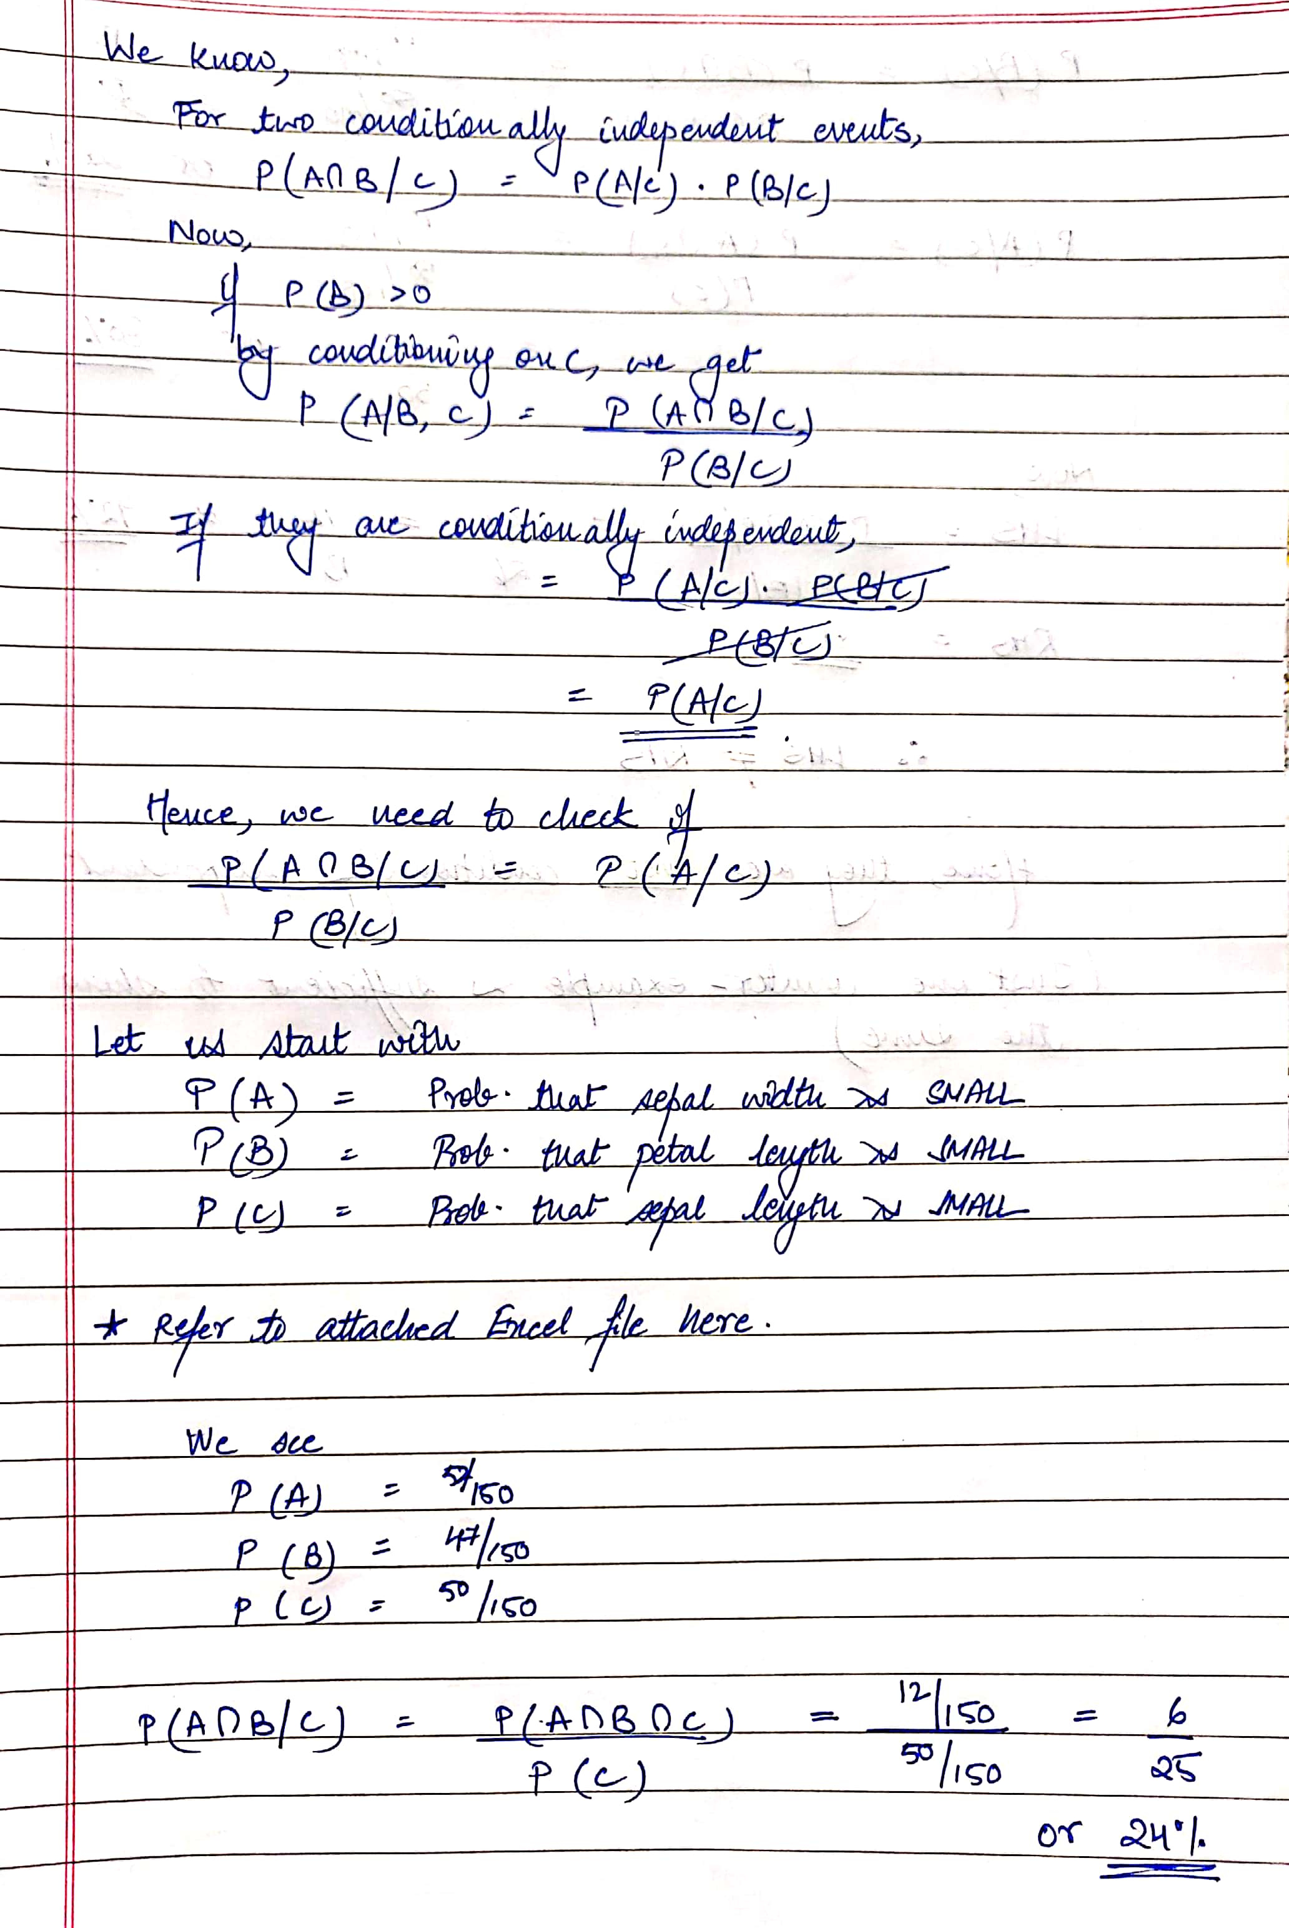
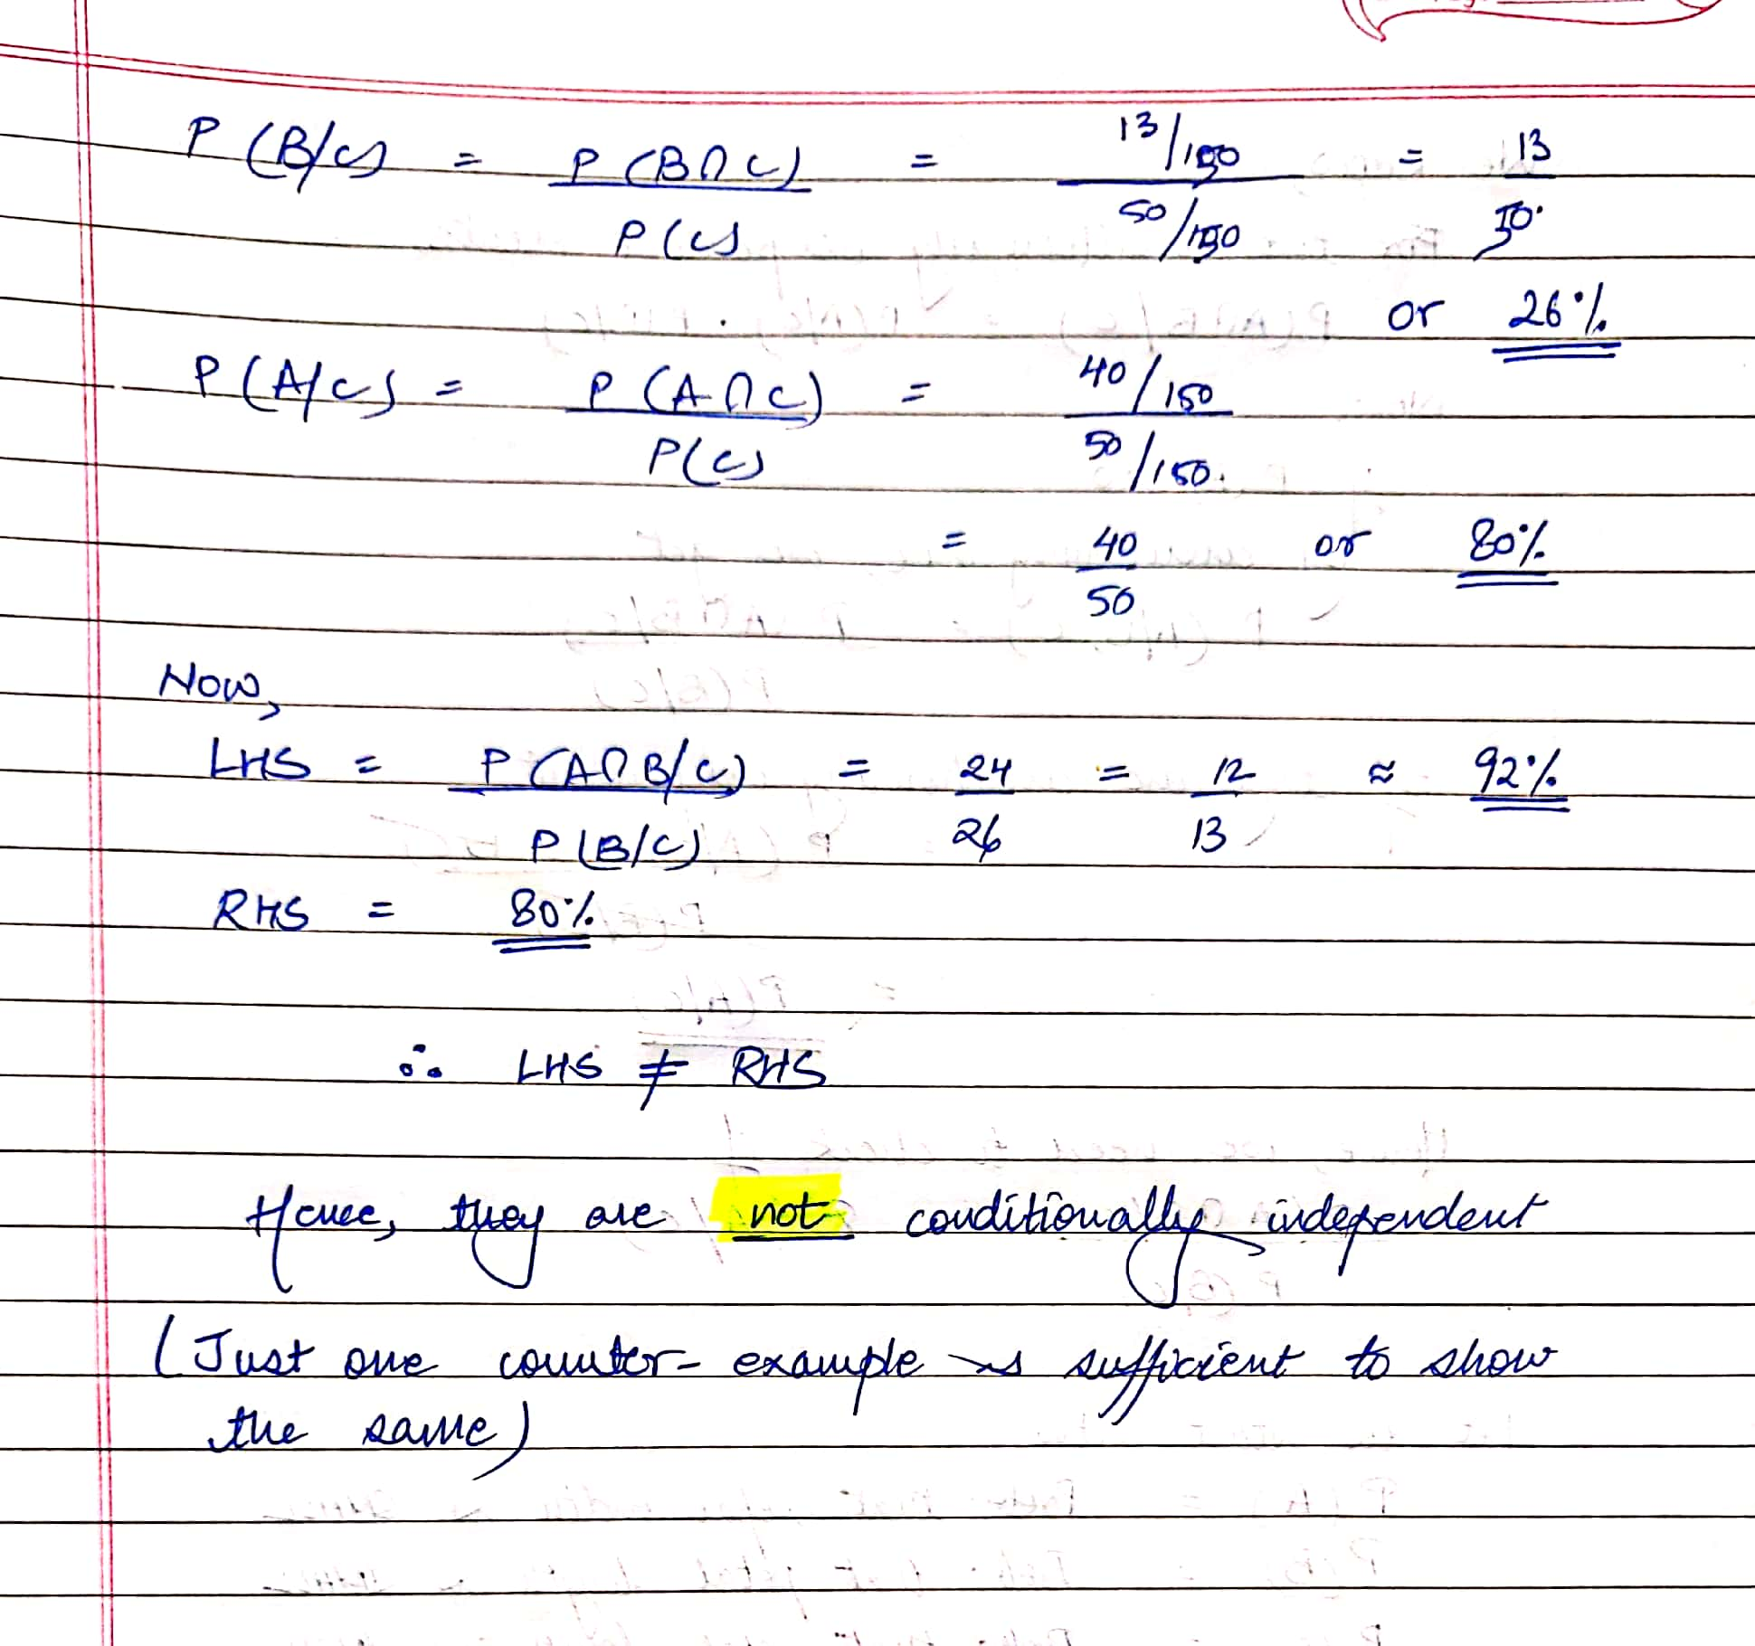

PracticalTExercises
1.TFindingTDatasets:T(a)TWhatTkindTofTfileTformatTdoesTWekaTuse?T(b)TAreTthereTanyTsuchTdatasetsTonTyourTcomputer?T(c)TFindTatTleastToneTandTloadTitTintoTWekaT(GoTtoT/TandTrunTfindTcommand)T(d)TRecordTtheTdatasetTandTyourTobservationsT(RYO)T(e)TAreTanyTofTtheTattributesTcorrelatedTinTtheTdatasetTyouTloaded.

Answer:
  - a)TWekaTusesT.arffTfileTformat.TarffTstandsTforTattributeTrelationTfileTformat.TItTisTanTASCIITtextTfileTthatTdescribesTaTlistTofTinstancesTsharingTaTsetTofTattributes.TItTisTanTextensionTofTCSV.TWekaTalsoTsupportsTtheTfollowingTfileTformats:
- .arff.gz
- .names
- .data
- .csv
- .json
- .json.gz
- .libsvm
- .m
- .dat
- .bsi
- .xrff
- .xrff.gz
  - b)TNo,TmyTcomputerTdidTnotThaveTanyTsuchTdatasets.THowever,TsomeTdatasetsTcomeTpreinstalledTwithTWekaTandTcanTbeTfoundTatTC:\ProgramTFiles\Weka-3-8-4\data.
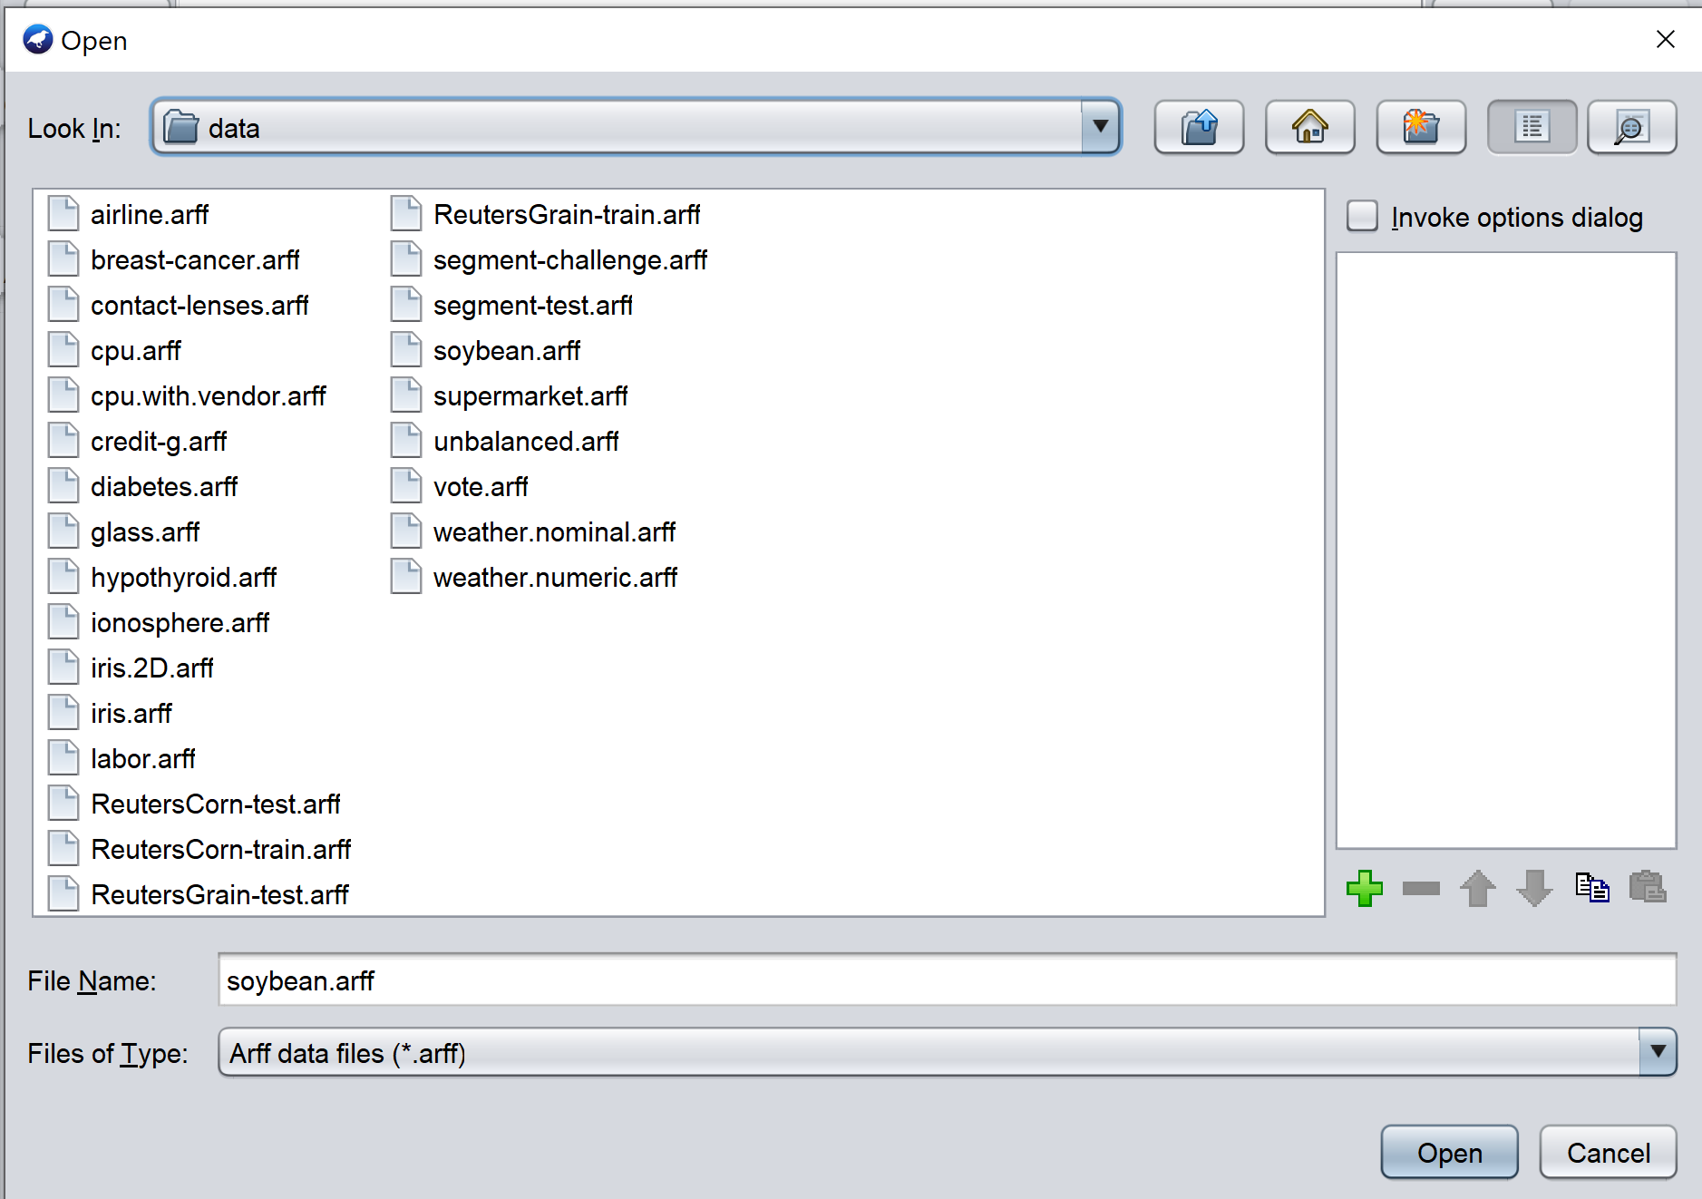

  - c)TForTmyTobservations,TITusedTtheTWekaTdatasetTcalledTsoybean.arff
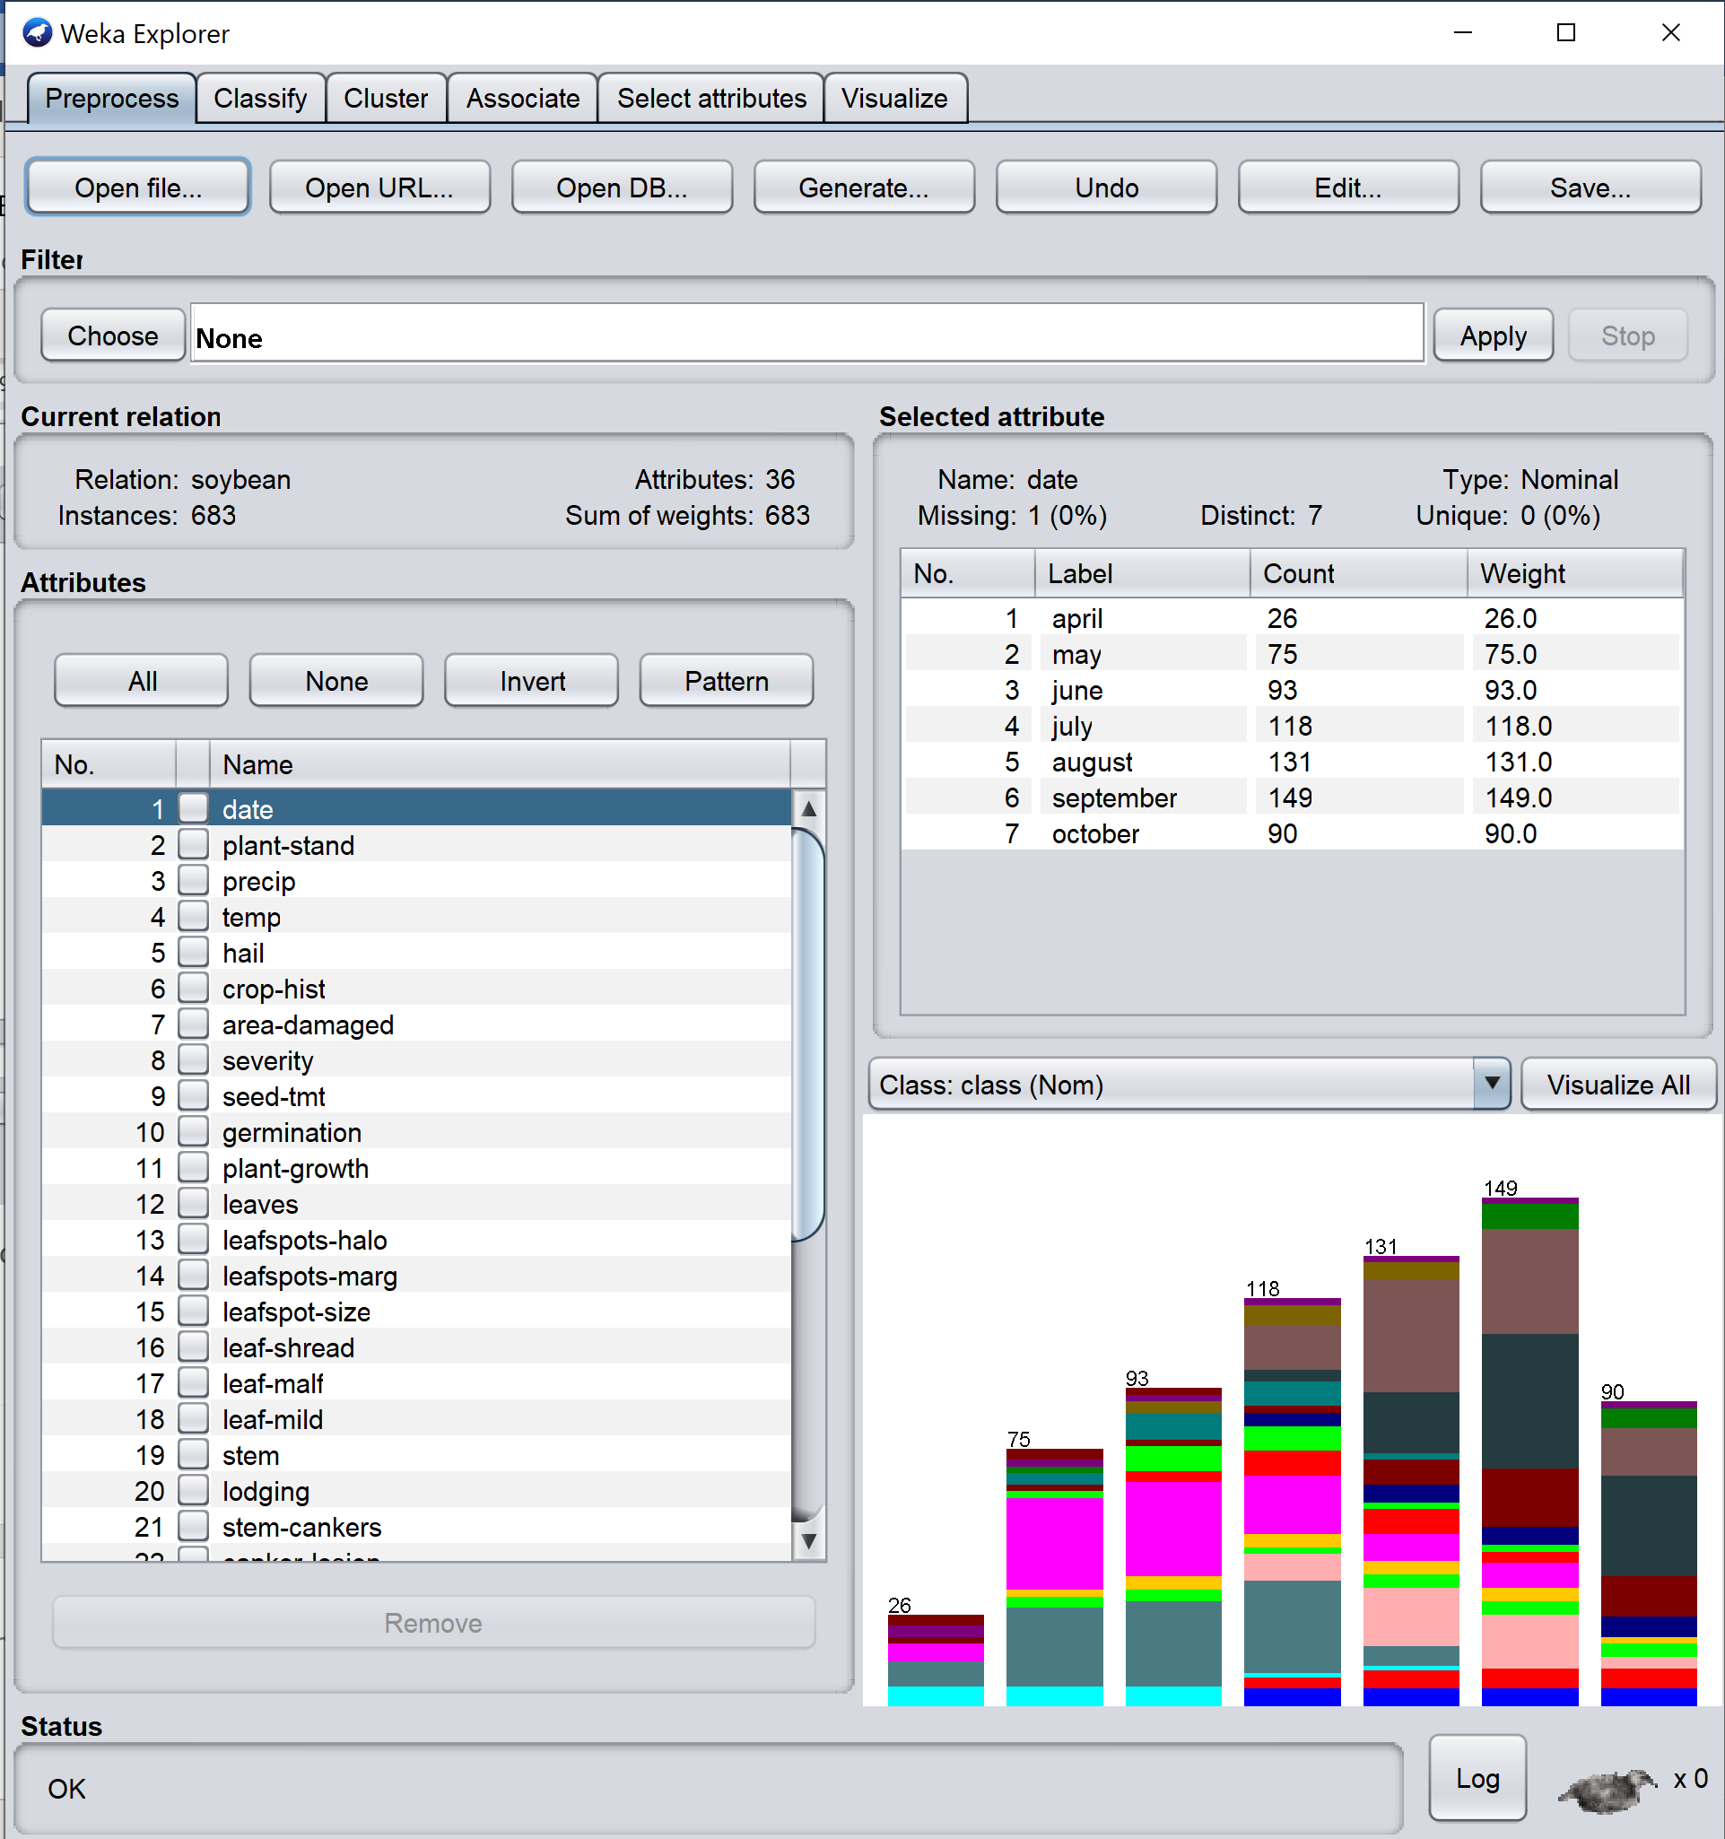

  - d)TTheTdataTsetTcontainsT36Tattributes.TEachTattributeThasTaboutT10-15Tclasses.TMostTofTthemTareTnominal.TThereTareT683Tinstances.TWeTcanTseeTbarTgraphsTcreatedTforTeachTattribute.TThereTareTvariousTfunctionsTpresentTtoTfilter,Tcluster,Tclassify,TandTassociateTtheTdataset.
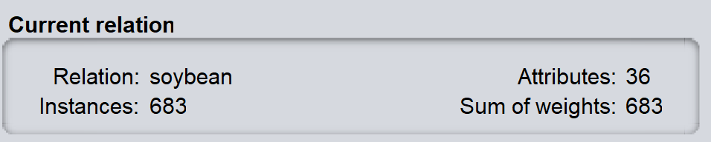

  - e)TPleaseTreferTtoTtheTscreenshot.
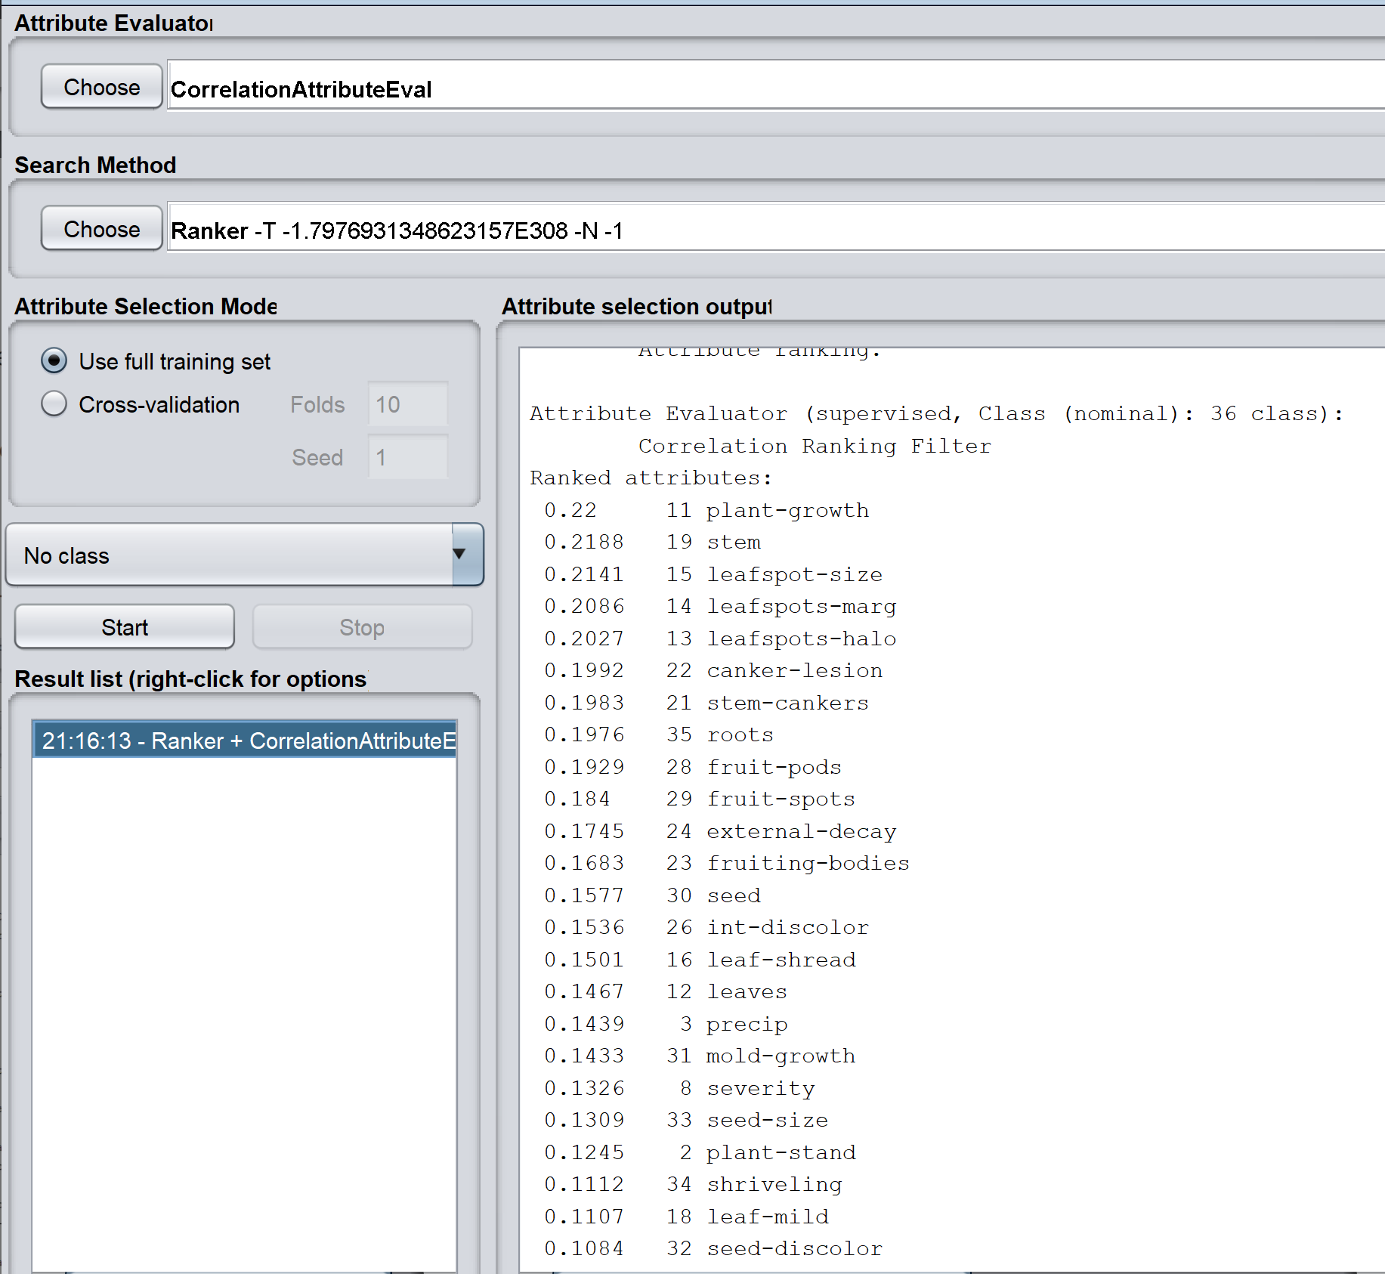

2.T(a)TGetTsecurityTdatasetsTfromTtheTUCITMachineTLearningTrepository.TLetsTuseTtheTPhishingTwebsiteTdatasetT(preferablyToneTwhichThasT1353Tinstances,TorT11000Tinstances)T(b)TUseTtheTExplorerTtabTinTWekaT(c)TUnderstandTtheTfeaturesTfromTtheTdocumentationT(d)THowTmanyTinstancesTareTthereTinTtheTdataset???TRYOT(e)TLoadTtheTdatasetTintoTWekaT(f)TVisualizeTandTRYOT(g)TFindTInformationTGain

Answer:
a)T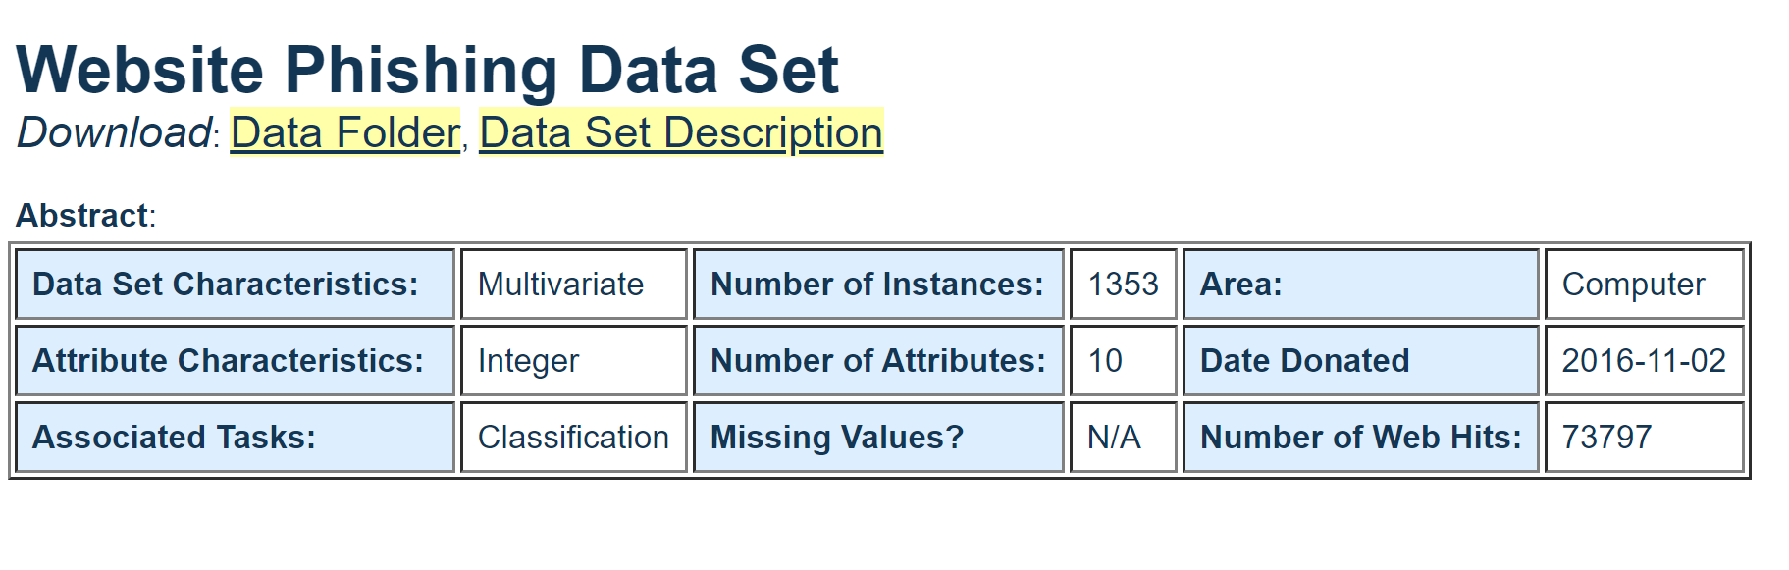
  - b)TWekaTExplorerTTab
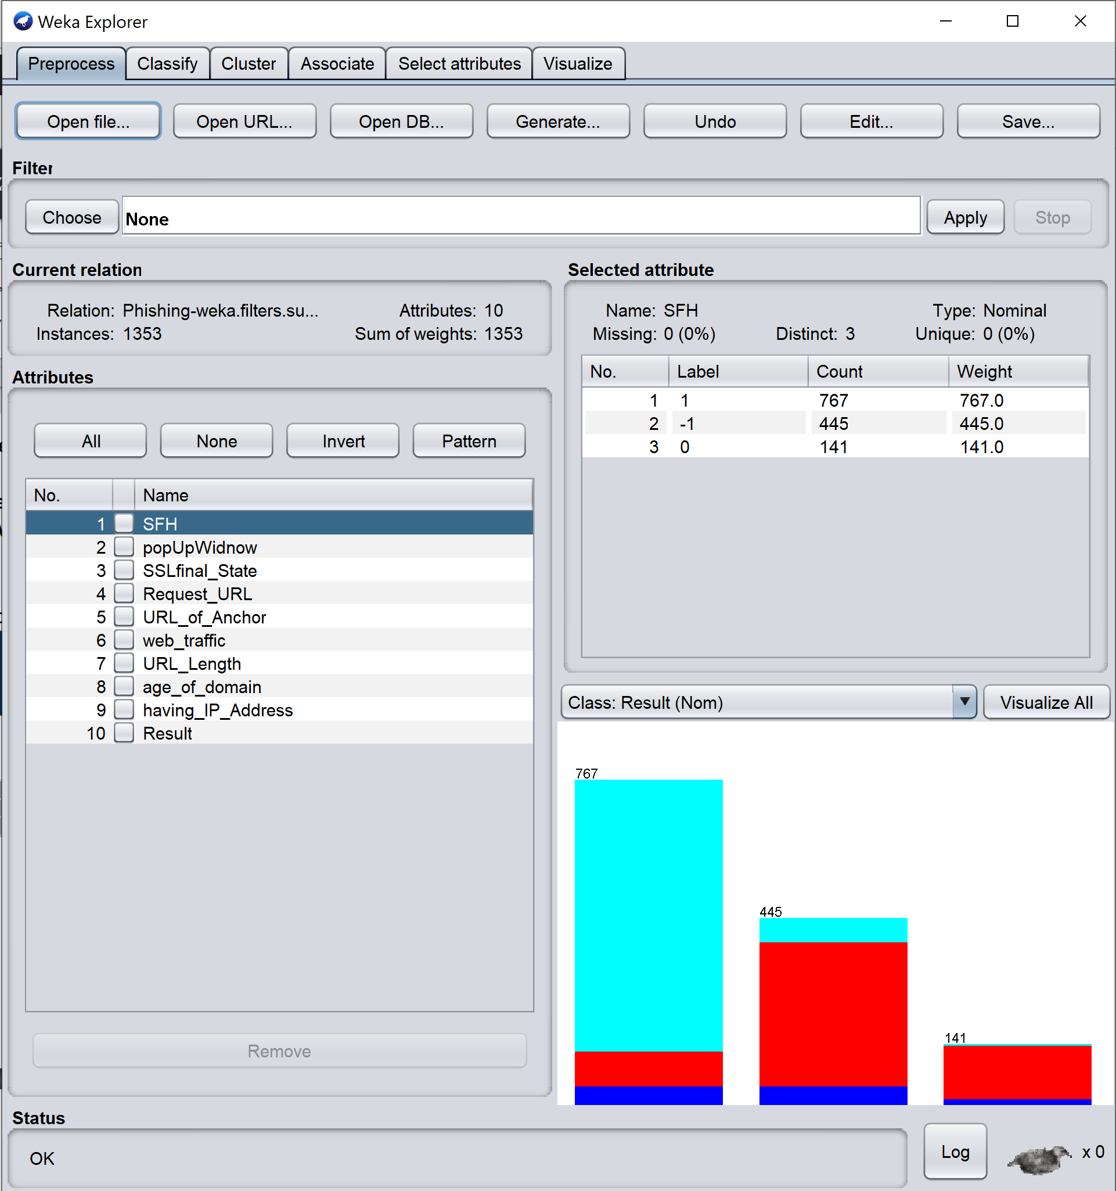
  - c)TDataTSetTInformation:
  - TheTphishingTproblemTisTconsideredTaTvitalTissueTinTtheTsecurityTindustryTespeciallyTe-bankingTandTe-commerceTtakingTtheTnumberTofTonlineTtransactionsTinvolvingTpayments.
WeThaveTidentifiedTdifferentTfeaturesTrelatedTtoTlegitimateTandTphishyTwebsitesTandTcollectedT1353TdifferentTwebsitesTfromTdifferenceTsources.TPhishingTwebsitesTwereTcollectedTfromTPhishtankTdataTarchiveT(www.phishtank.com),TwhichTisTaTfreeTcommunityTsiteTwhereTusersTcanTsubmit,Tverify,TtrackTandTshareTphishingTdata.TTheTlegitimateTwebsitesTwereTcollectedTfromTYahooTandTstartingTpointTdirectoriesTusingTaTwebTscriptTdevelopedTinTPHP.TTheTPHPTscriptTwasTpluggedTwithTaTbrowserTandTweTcollectedT548TlegitimateTwebsitesToutTofT1353Twebsites.TThereTisT702TphishingTURLs,TandT103TsuspiciousTURLs.TWhenTaTwebsiteTisTconsideredTSUSPICIOUSTthatTmeansTitTcanTbeTeitherTphishyTorTlegitimate,TmeaningTtheTwebsiteTheldTsomeTlegitTandTphishyTfeatures.
  - AttributeTInformation:
  - URLTAnchor
RequestTURL
SFH
URLTLength
Prefix/Suffix
IP
SubTDomain
WebTtraffic
DomainTage
Class
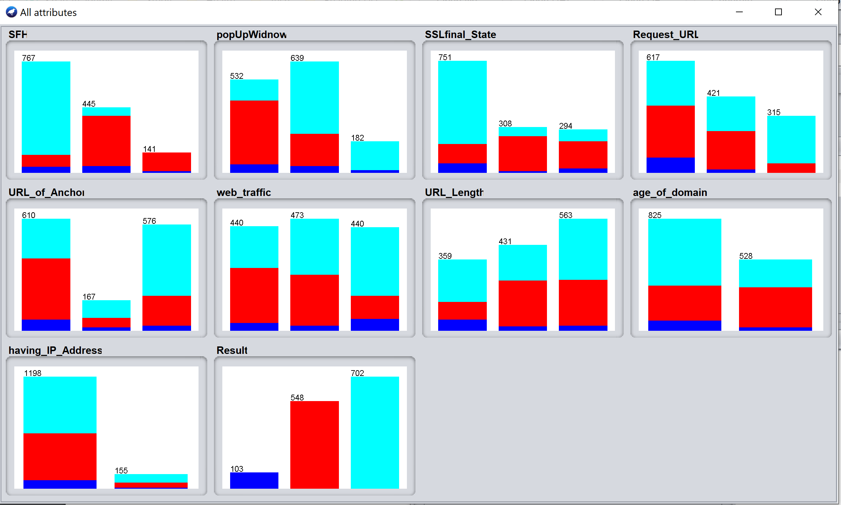

  - d)T1353Tinstances
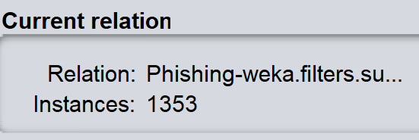

  - e)TLoadedTintoTWeka

  - f)TSomeTofTtheTvariousTpossibleTvisualisations
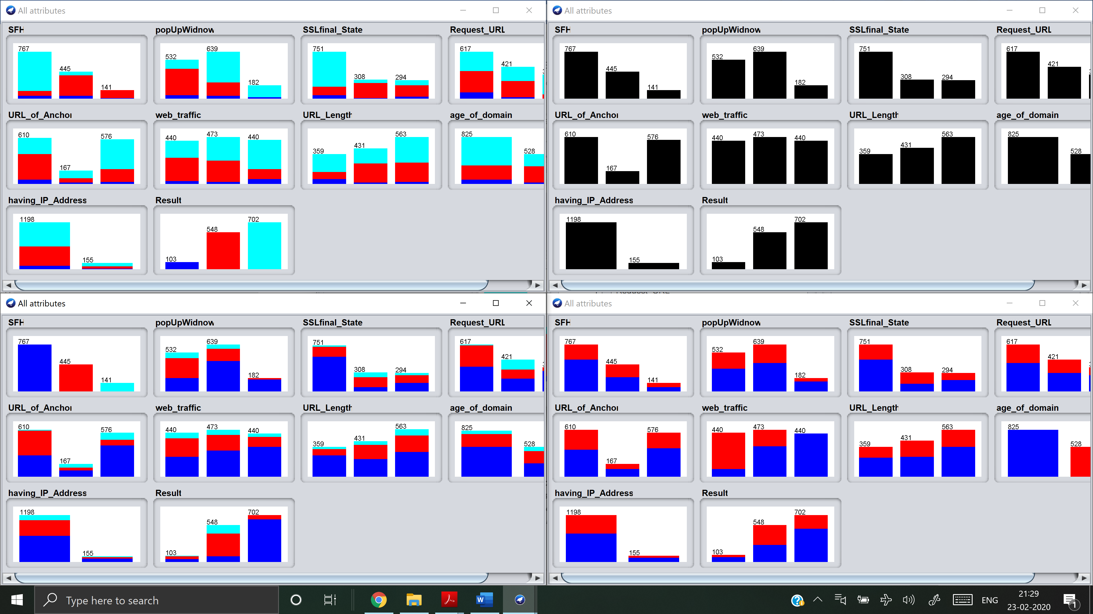
  - ThereTareT10TattributesTpresent.TEachTattributeThasT3TclassesT{-1,0,1}TexceptTattributeT“having_IP_address”TwhichThasTonlyT2.TTheTdataTisTunevenlyTspread.TAllTattributesTareTNominalTinTtype.

g)T
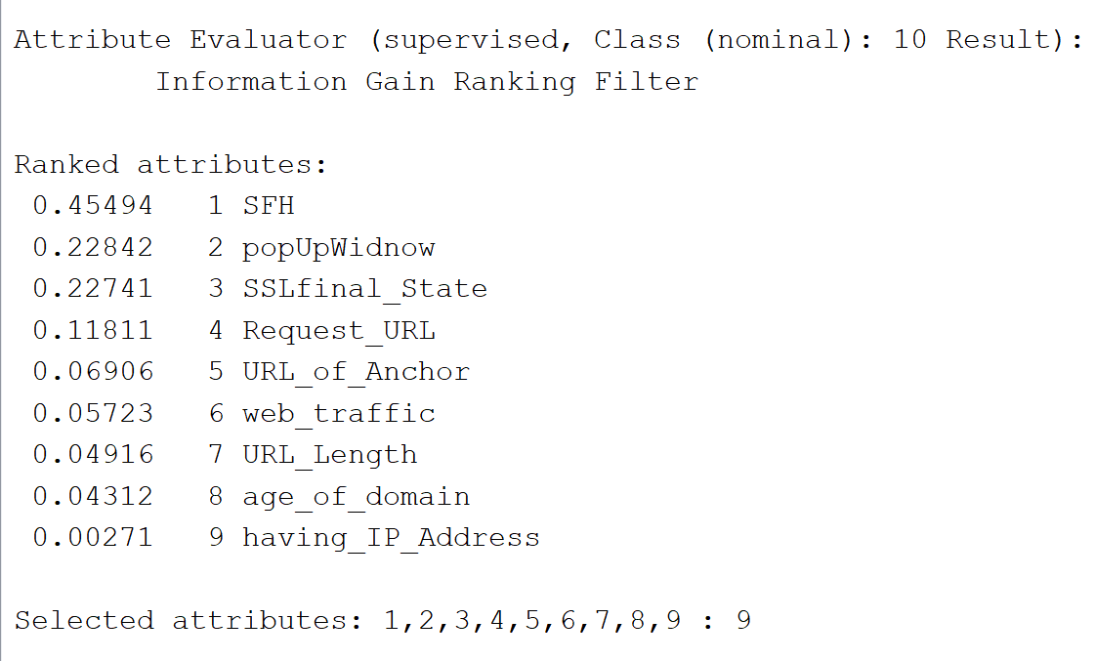

3.T(a)TDecisionTTreesT(WhatTdoesTWekaTcallTitsTdecisionTtreeTclassifiersTandTwhy?)T(b)TRecordTtheTconfusionTmatrixTandTtheTweightedTRecallTPrecisionTF-scoreTresultsTyouTgetT(c)TExamineTtheTmodelThowTdeepTisTtheTdecisionTtree?TCanTyouTgenerateTrulesTfromTtheTdecisionTtree?T(d)TNowTselectTtheTattributeTwithTtheThighestTinformationTgainTandTjustTdoTaTdecisionTtreeTusingTthisTattribute?TWhatTareTtheTresults?TCompareTwithTtheTpreviousTstepTwithTallTattributes?

Answer:

  - a)TThereTareTeightTdifferentTdecisionTtreeTclassifiersTinTWeka:
- J48
- DecisionStump
- RandomTree
- RandomForest
- REPTree
- M5P
- LMT
- HoeffdingTree
  - However,TtheTmostTcommonlyTusedToneTisTJ48,TwhichTisTcalledTsoTbecauseTitTusesTC4.5T(J48)TforTgeneratingTtheTtrees.

  - b)T
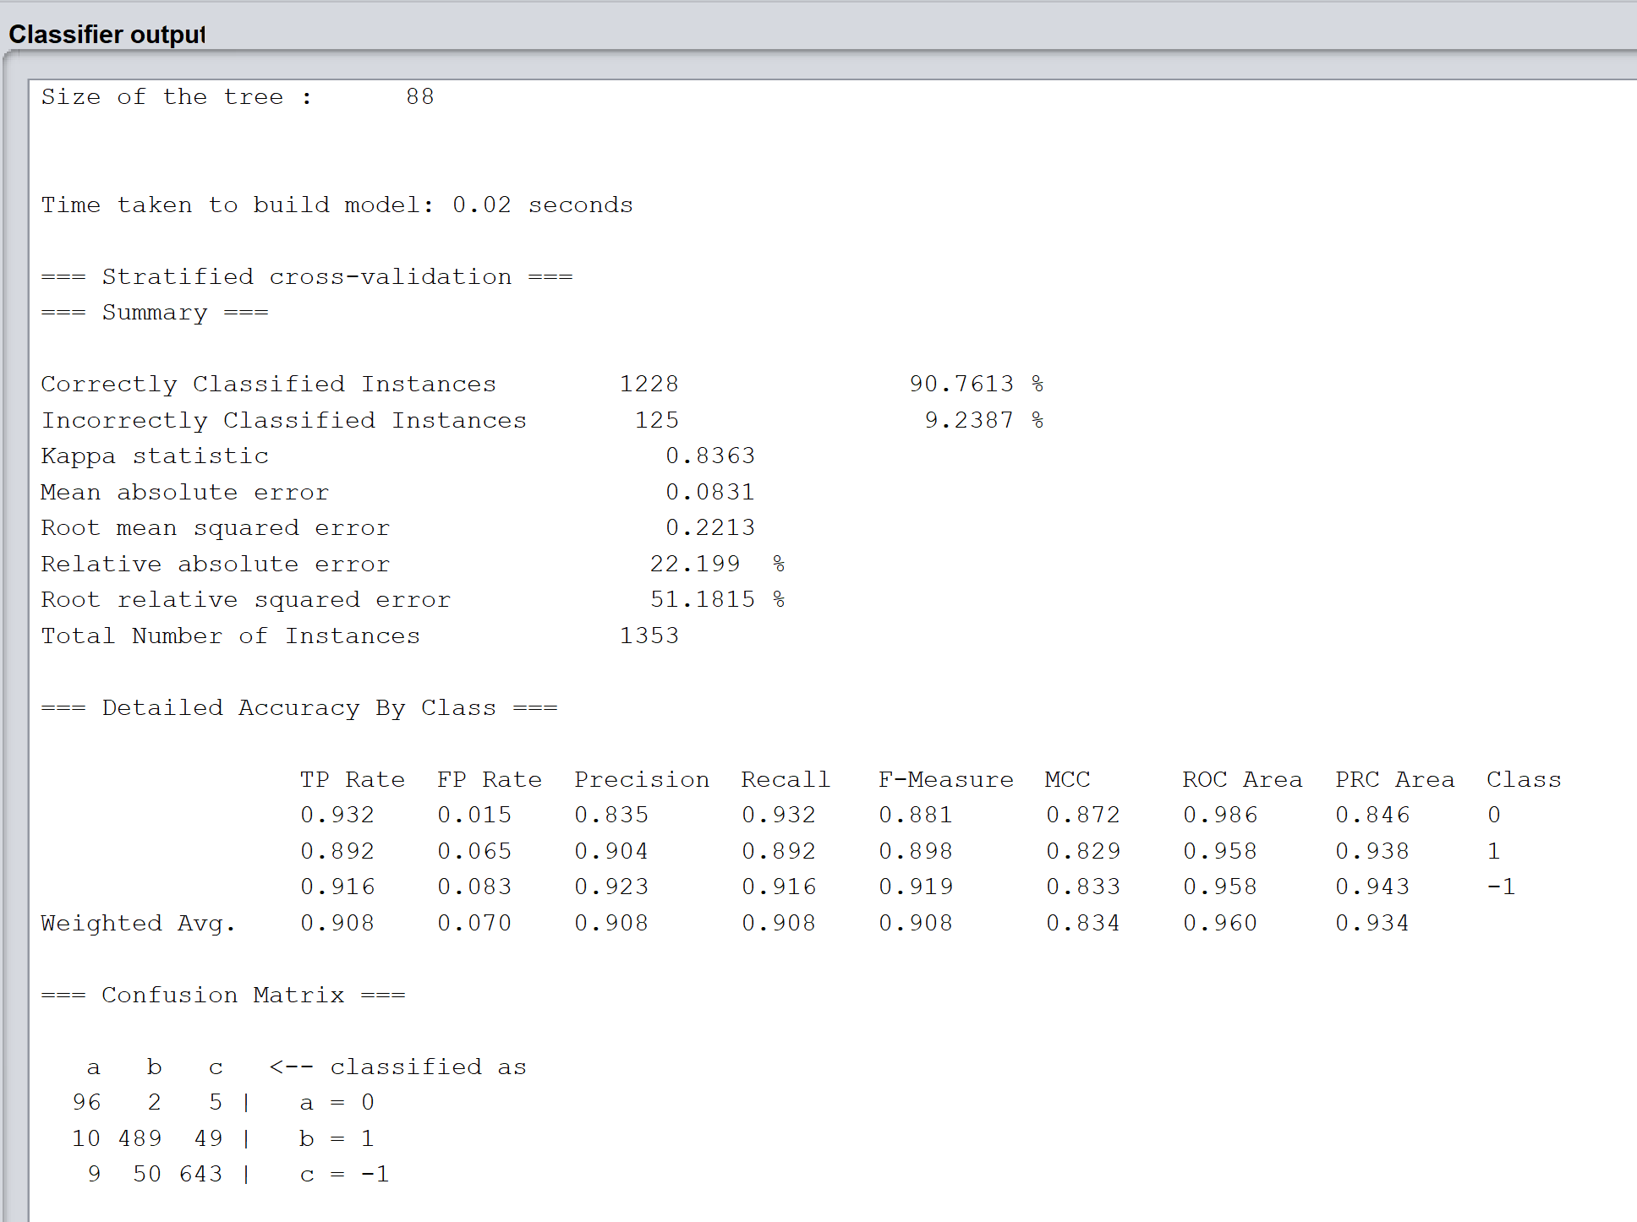

  - c)T
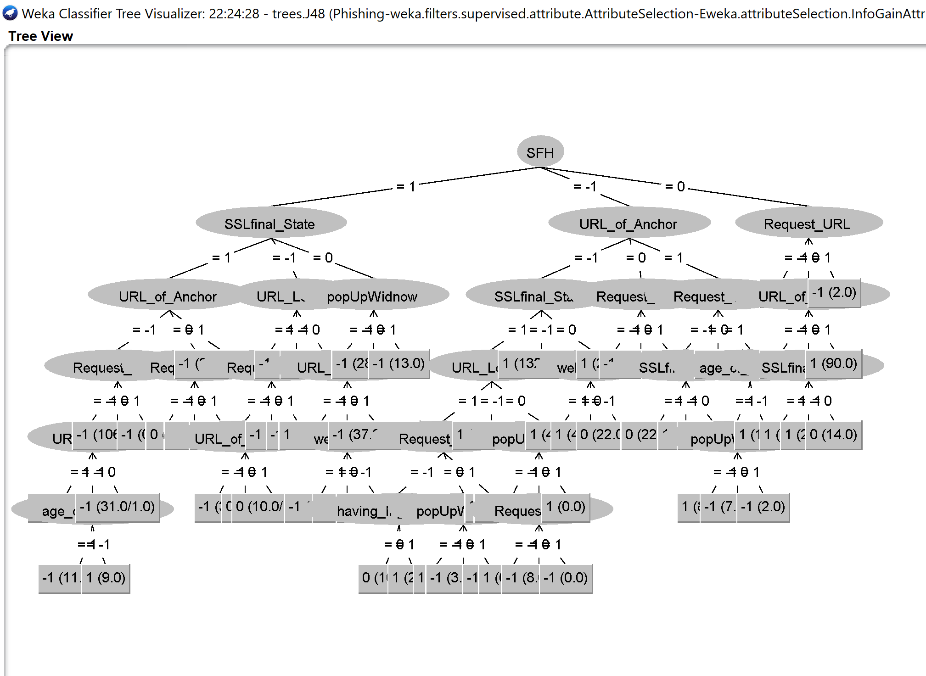
  - TheTdecisionTtreeTisT7TlevelsTdeep.
  - Yes,TweTcanTgenerateTrulesTthroughTtheTdecisionTtreeTthroughTtraversingTaTpathTfromTtheTrootTnodeTtoTanyTleafTnode.

  - d)T
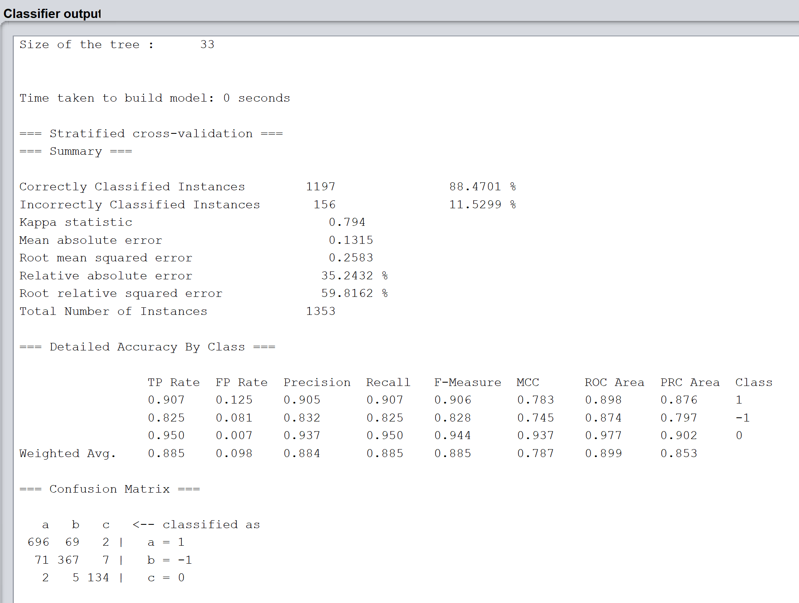
  - AllTtheTattributesTforTcomparisonTareTavailableTinTtheTtwoTscreenshots.

4.TAprioriTalgorithm:T(a)TUseTaTsupportTthresholdTofT0.1,TandTfindTfrequentTitemsetsT(b)TThenTuseTconfidenceTofT0.8TwithTtheTsameTsupportTthresholdTAreTthereTanyTrules?T(c)TIncreaseTsupportTtoT0.5TandTfindTfrequentTitemsetsT(d)TIsTtheTdatasetTunbalanced?THowTdoTyouTfindTout?T(e)TCreateTanTunbalancedTdatasetTofTratioT1:10TusingTrandomTselectionT(f)TRunTdecisionTtreeTalgorithmTonTunbalancedTdatasetTT(g)TCompareTtheTresultsTforT2TclassesTwithTbalancedTversusTunbalanced.

Answer:

a)
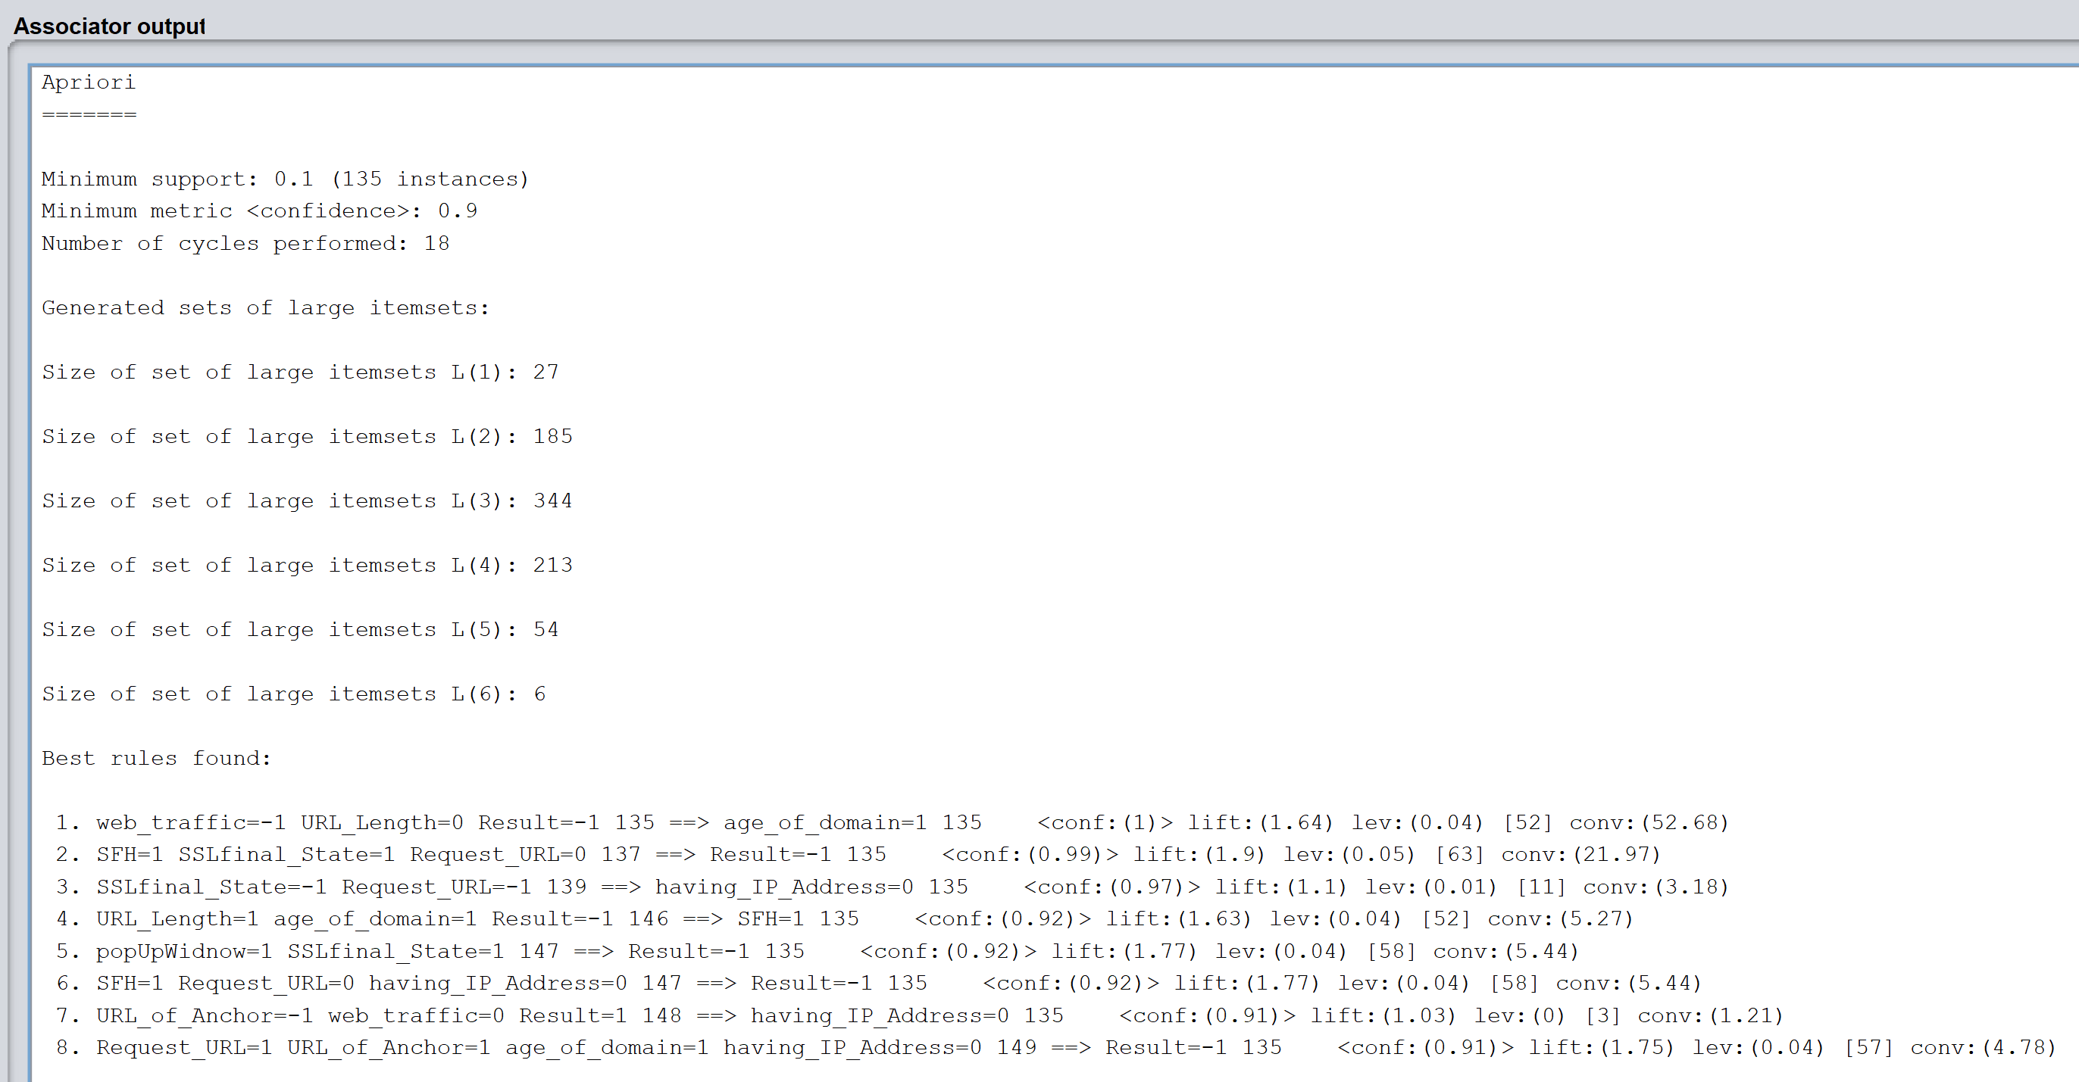

b)T
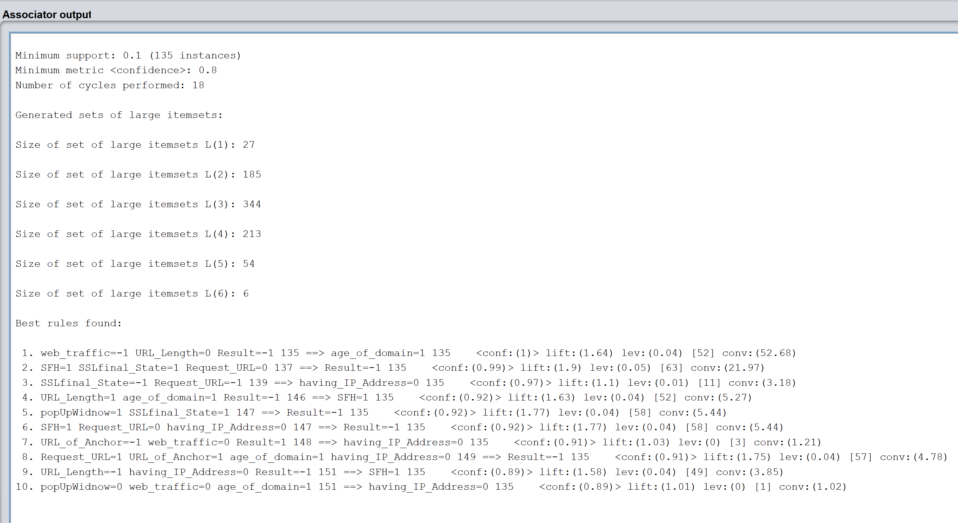

c)T
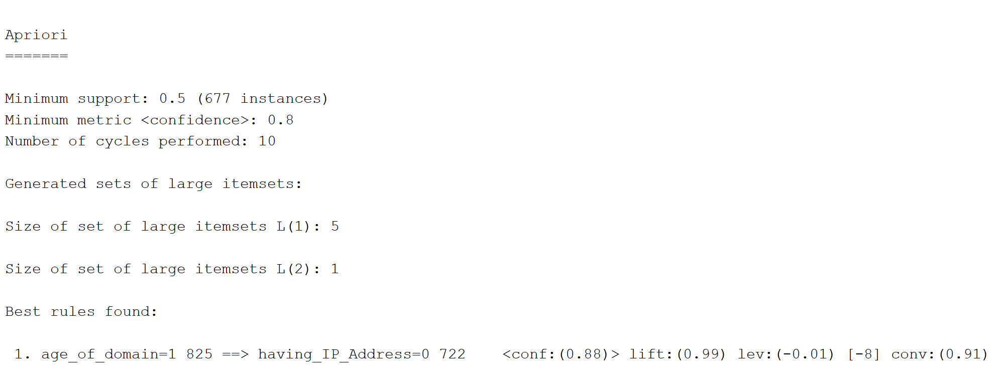

d)
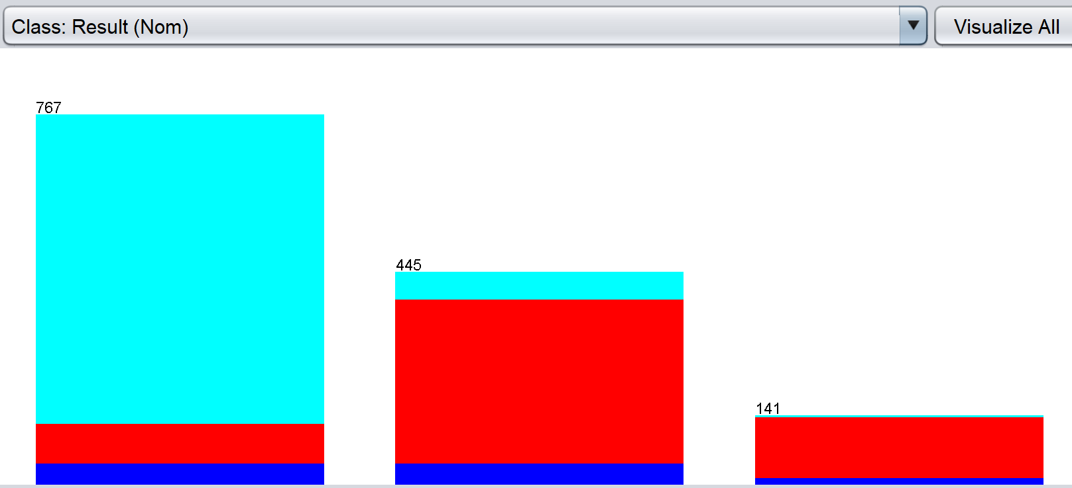

  - Clearly,TtheTdataTisTindeedTunbalanced.

e)T
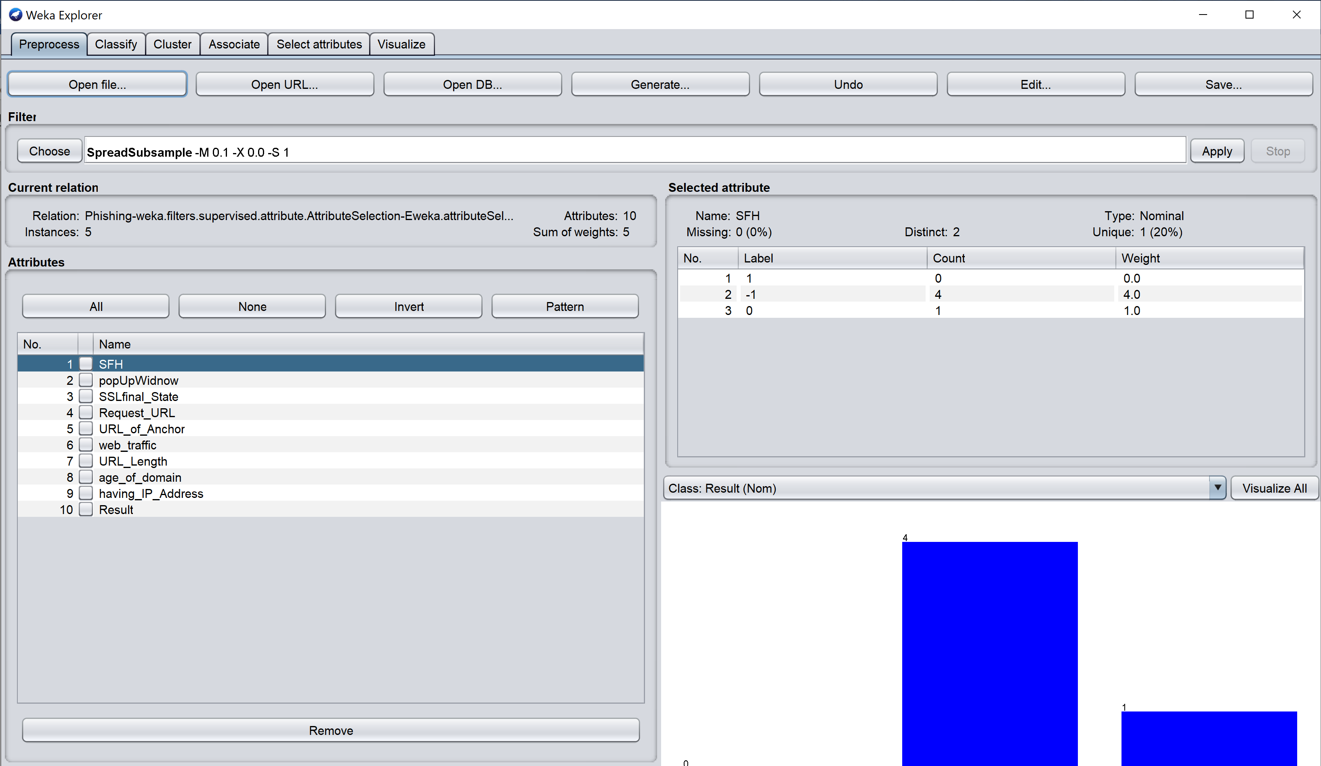

f)
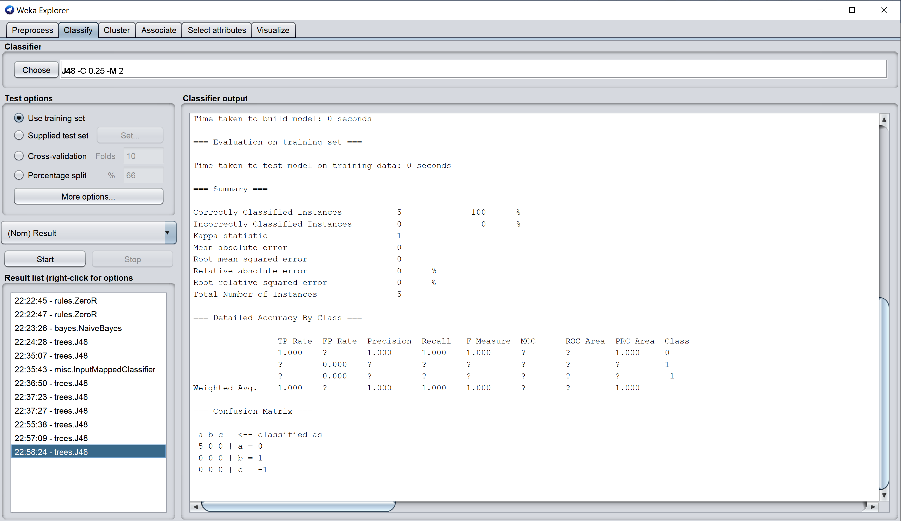

g)TForTBalancedTSetT->
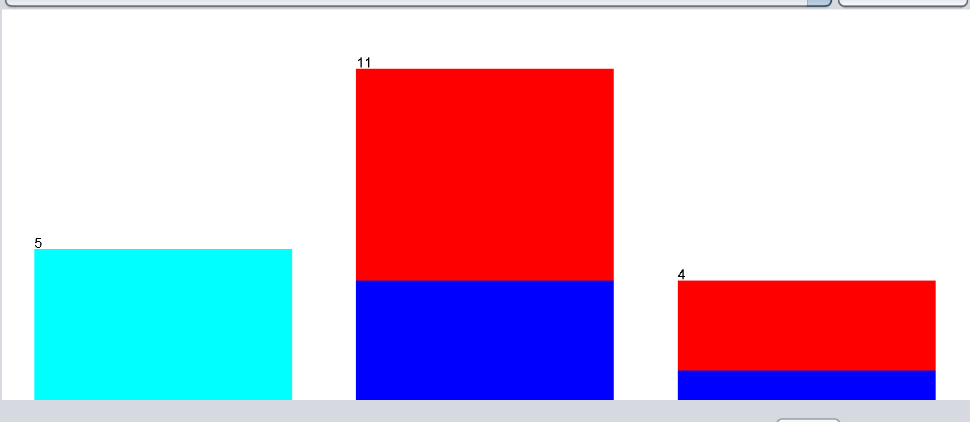
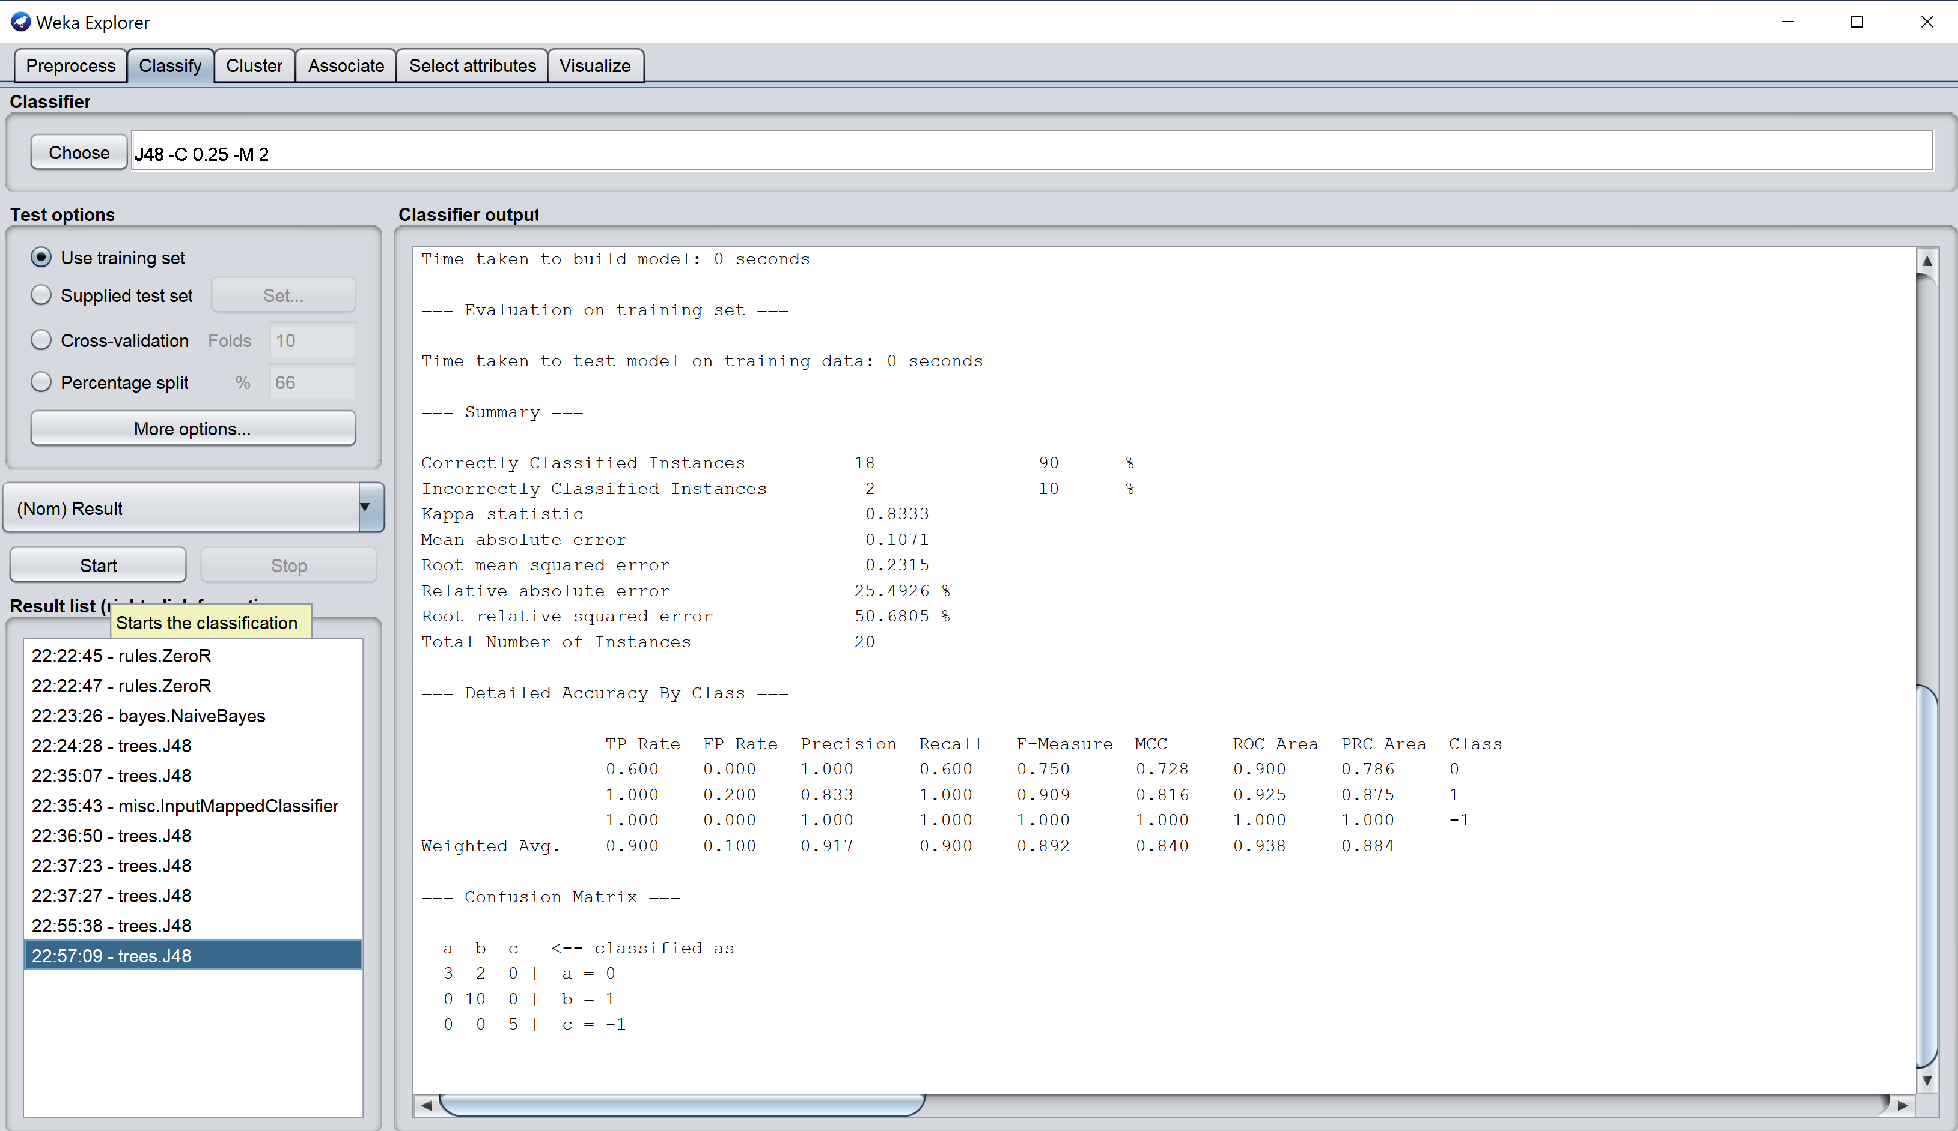

5.T(a)TRunTtheTdecisionTtreeTclassifierTwithT10TfoldTcrossTvalidationT(b)TRecordTtheTaverageTresultsT(c)TIfTyouTdidT10TfoldTbefore,TdoT5TfoldTcrossTvalidationT(d)TCompareTresultsTandTmodelTsizesT(RYO)T(e)TRunTK-meansTclusteringTwithTK=2TorTK=3T(sameTasTnumberTofTclasses)T(f)TCanTyouTmeasureTtheTpurityTofTyourTclusters?T(g)TCanTyouTdoTanomalyTdetectionTinTWeka?TIfTso,Thow?

Answer:

a)
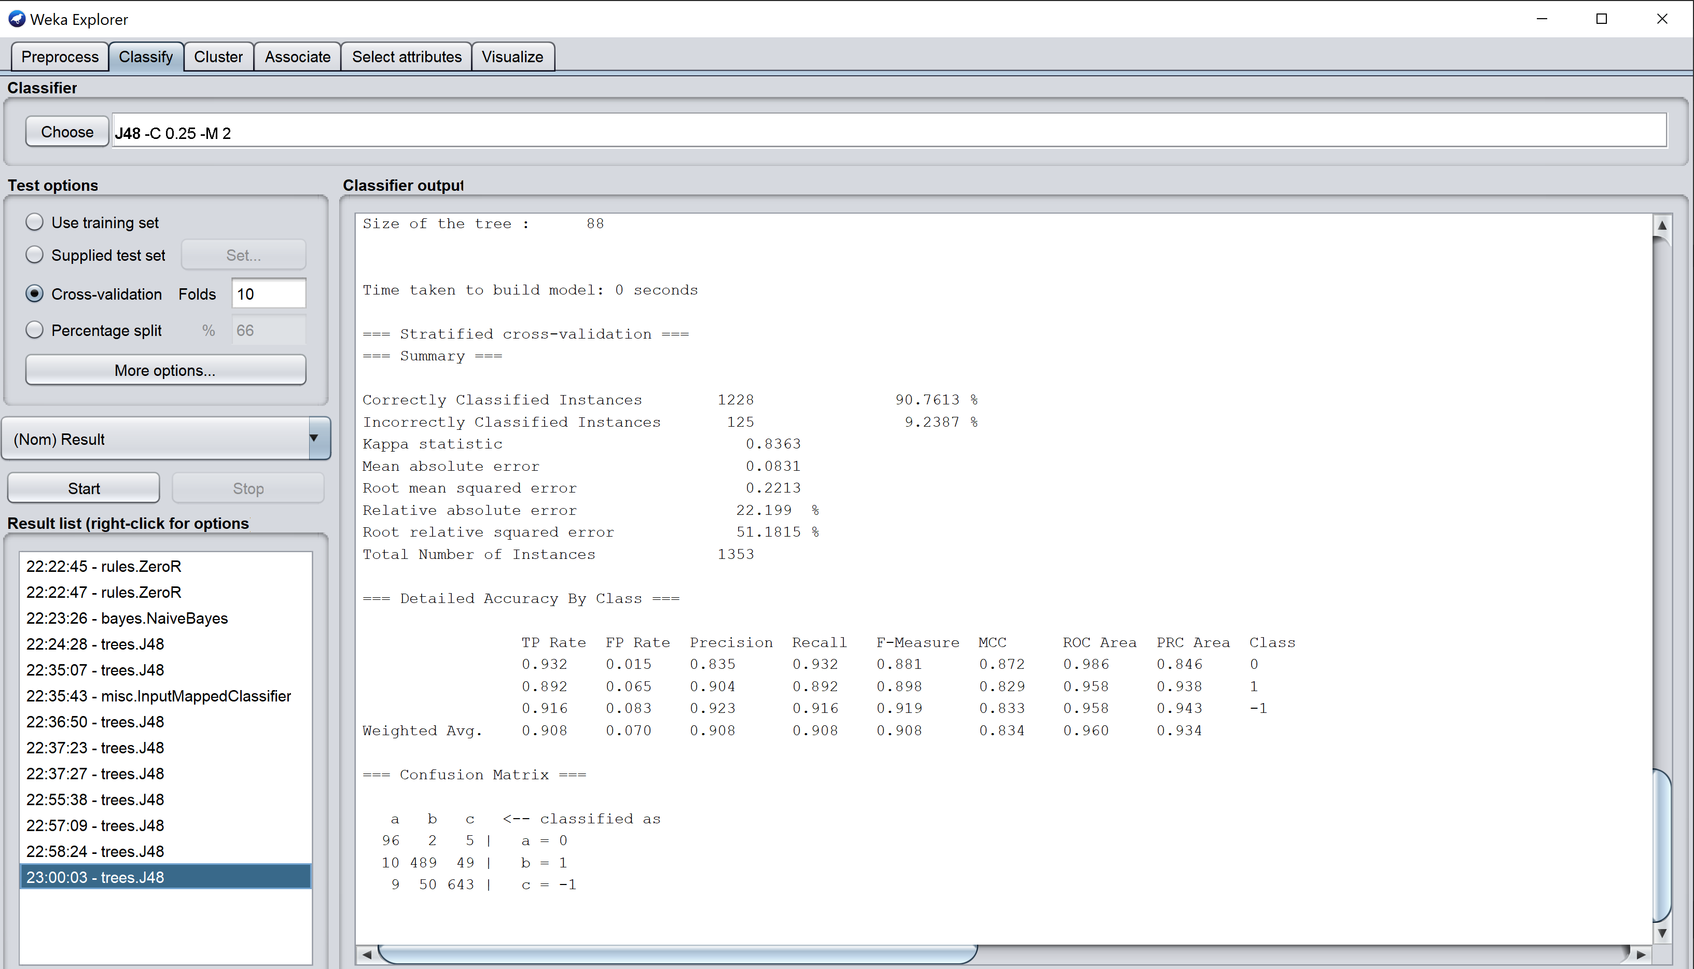

b)
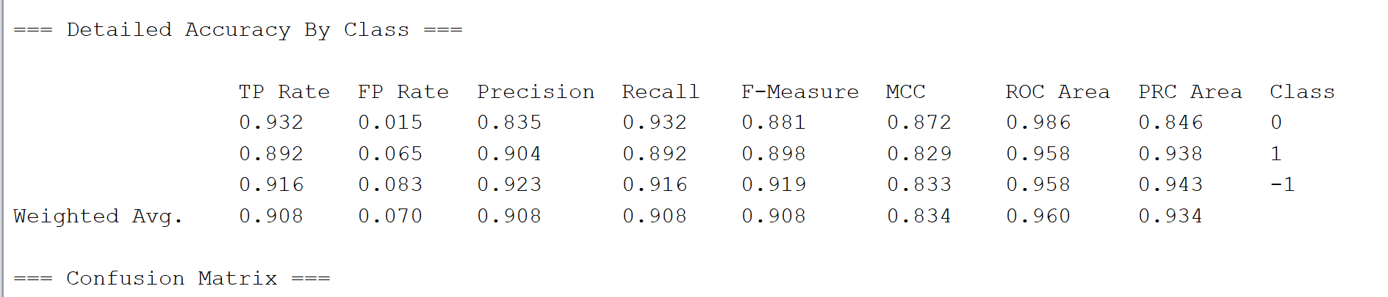

c)
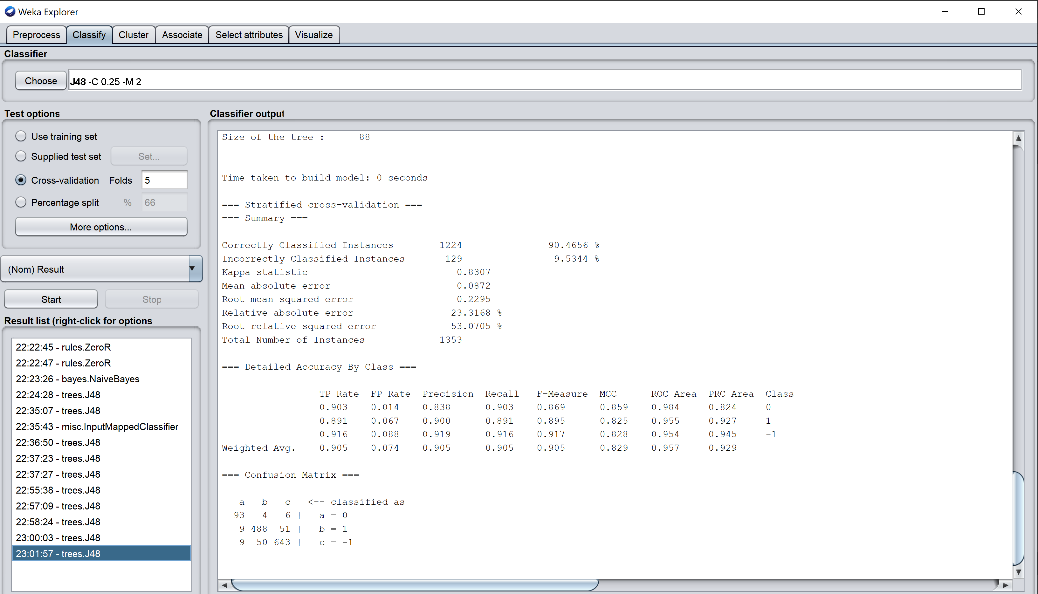

d)
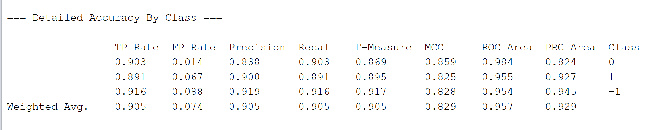

e)Tk=3
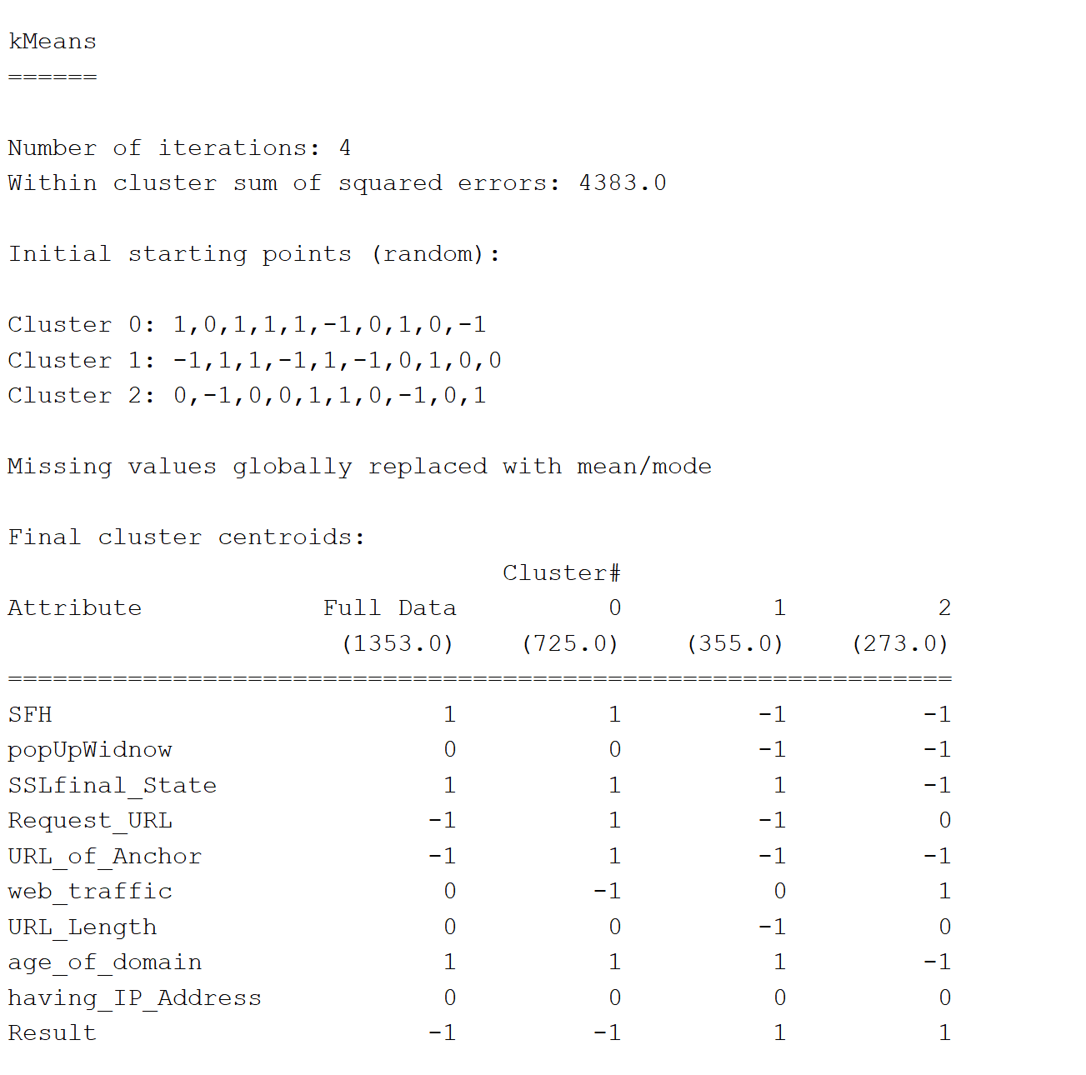

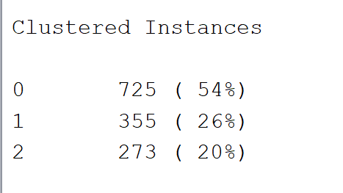

  - f)T
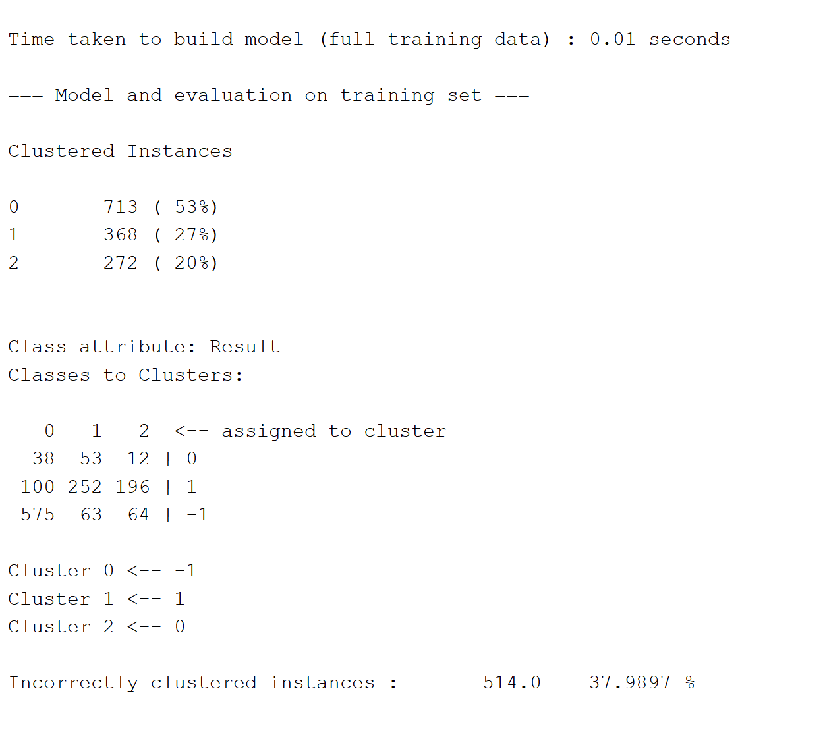

  - PURITYT->
  - ClusterT0:T38/(38+100+575)T=T38/713T=T0.05
  - ClusterT1:T252/(53+252+63)T=T252/368T=T0.68
  - ClusterT2T=T64/(12+196+64)T=T64/272T=T0.24

  - g)TYES
  - WekaThasTaTLibsvmTpackageTwhichTincludesTtheTone-classTSupportTVectorTMachineT(SVM)TclassifierTwhichTisTquiteTwidelyTusedTforToutlierTdetectionTproblems.
  - --TSchölkopf,TB.,TJ.TC.TPlatt,TetTal.T(2001).T"EstimatingTtheTSupportTofTaTHigh-DimensionalTDistribution."TNeuralTComputationT13(7):T1443-1471.

